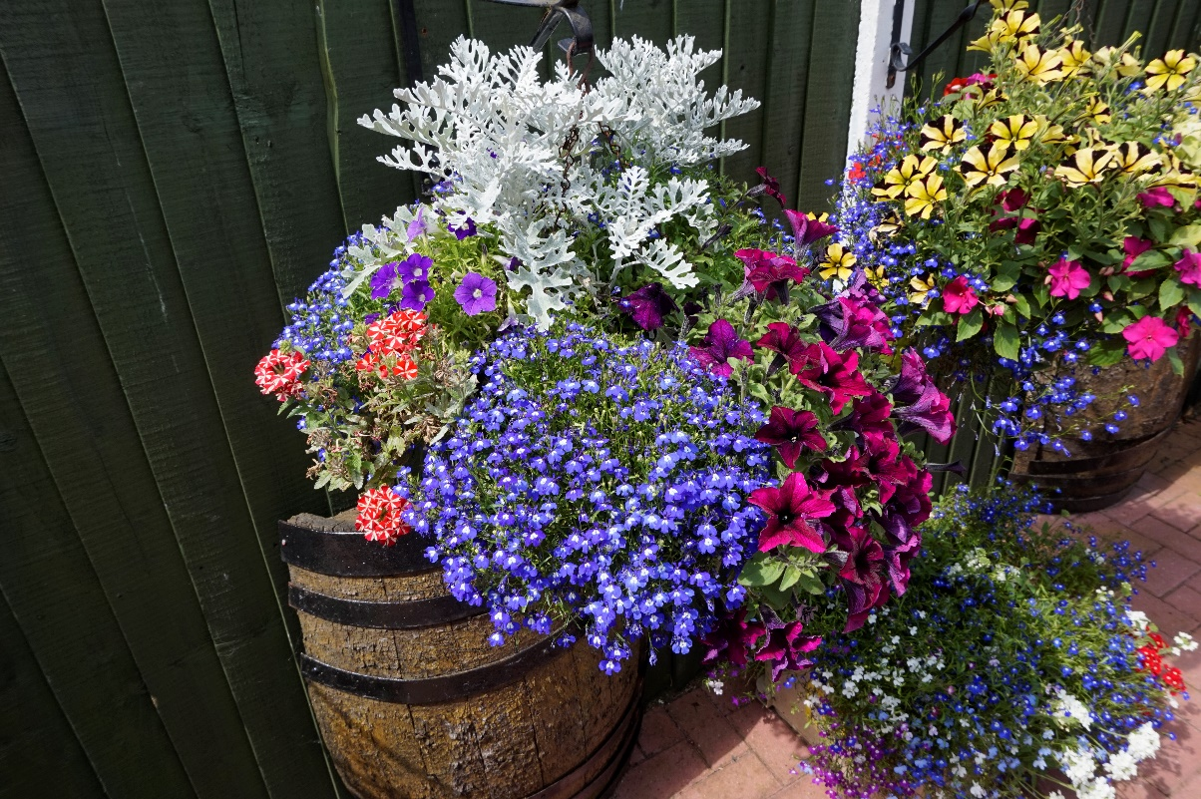

Market Drayton Town Council

Garden Competition

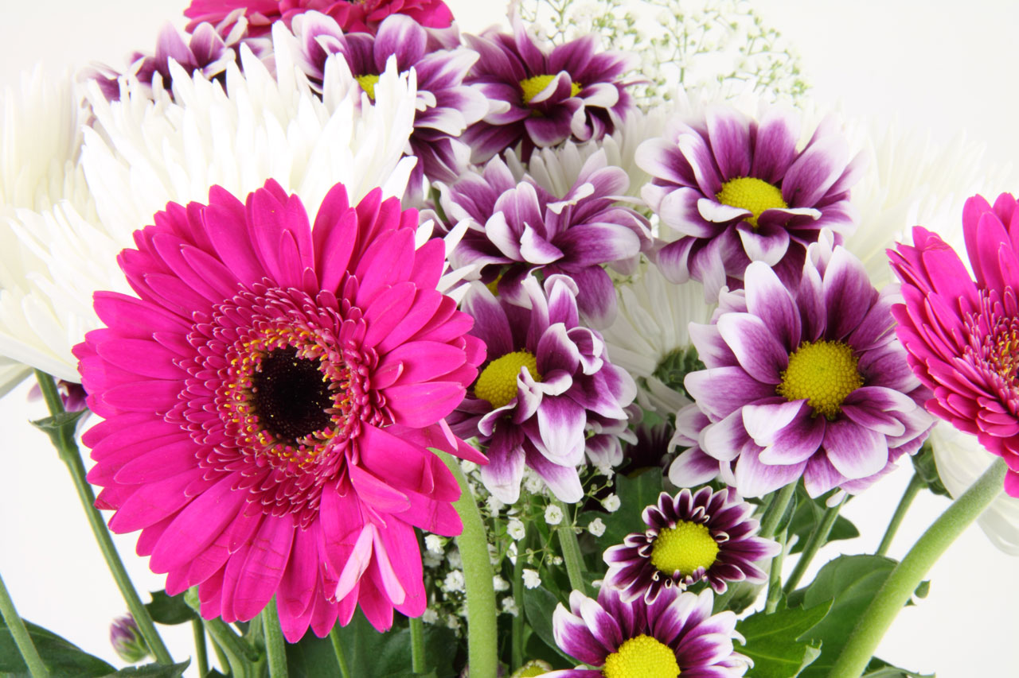

**Residential Entries**

[ ] Best Front Garden

[ ] Best Back Garden

[ ] Best Patio Display

[ ] Best Allotment/Vegetable Garden

[ ] Best Water Garden

[ ] Environmentally Friendly Garden

[ ] Best Group Dwelling

[ ] Best Hanging Basket/Planter/Window Box

[ ] Best School

[ ] Best Child’s Garden (under 14)

**Business Entries**

[ ] Best Shop

[ ] Best Small Business

[ ] Best Large Business

[ ] Best Public Building

[ ] Best Licensed Premises

[ ] Best Hanging Basket

[ ] Best Overall Hanging Basket

In Bloom Summer 2019—Application Form

**Entry:**

**Please indicate which categories you wish to**

**enter (above) and complete the details opposite.**

**The winner of each category will receive a prize**

**and a trophy to be held for one year, presented**

**at an awards ceremony in September.**

**Return this form to: The Town Hall,**

**18 Frogmore Road, Market Drayton, TF9 3AX.**

**Telephone: 01630 653364 or**

**email: admin@marketdrayton.gov.uk**

**Closing date for entries is Friday 12th July 2019.**

**Your details**

Name:

Address:

Contact Number:

Image : Mike Smith

**Market Drayton**

**Town Council**

Image : Mike Smith