Dear Members 8 April 2016

In Bloom Sub Committee

You are hereby summoned to a meeting of the In Bloom Sub Committee at 7.00pm on Thursday 14 April 2016 in the Town Hall Chamber, Frogmore Road, Market Drayton.

AGENDA

16.354.IB APOLOGIES – To receive apologies for absence.

16.355.IB DISCLOSABLE PECUNIARY INTERESTS – Members are reminded that they must not participate in the discussion or voting on any matter in which they have a Disclosable Pecuniary Interest and should leave the room prior to the commencement of the debate.

16.356.IB MINUTES – To agree and confirm the minutes of a meeting of the In Bloom Sub Committee held on 27 August 2015 (enclosed).

16.357.IB PREPARATION FOR THIS SEASON – To consider the preparations for this year’s season.

Yours faithfully

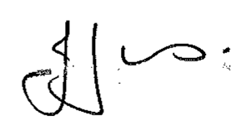

Julie Jones
Town Clerk

Membership: Cllrs T Beckett, J Beckett, M Erwin, R Hughes and V Taylor.

