Date: 20 January 2017

To: Town Mayor, Councillor D Minnery
Deputy Town Mayor, M Erwin (Vice Chairman)
Councillors: Mrs J. Beckett, Mr T Beckett, J Gough, R Hughes (Chairman), Mrs V Taylor, L Owen and C. Purcell

Also to: All Members of the Town Council for information.

Dear Councillor

You are required to attend an Extraordinary meeting of the Services & Facilities Committee to be held in the Council Chamber, Town Hall, Frogmore Road, Market Drayton, on Thursday 26 January 2017 starting at 6.45 pm. The meeting is open to the Press and Public.

Yours sincerely

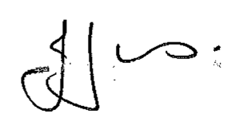

Julie Jones
Town Clerk

AGENDA

1.SF APOLOGIES

To receive apologies for absence.

2.SF DISCLOSABLE PECUNIARY INTERESTS

Members are reminded that they must not participate in the discussion or voting on any matter in which they have a Disclosable Pecuniary Interest and should leave the room prior to the commencement of the debate.

3.SF BUDGET 2017/18

To consider and agree the budget for this committee for the financial year 2017/18.

See Appendix A attached

