14 December 2018

To: All Members
Councillor M Whittle (Chairman), Councillor R Gould (Vice Chairman)

Dear Councillor

COMMUNITY AND GOVERNANCE COMMITTEE MEETING

You are hereby summoned to an Extraordinary meeting of the Community and Governance Committee to be held following the Planning Committee meeting in the Town Hall Council Chamber, Frogmore Road, Market Drayton on Thursday 20 December 2018.
The meeting is open to the press and public.

Yours faithfully

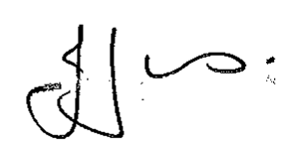

Julie Jones
Town Clerk
…………………………………………………………………………………………………………

AGENDA

1.CG APOLOGIES

To receive apologies for absence.

2.CG DISCLOSABLE PECUNIARY INTERESTS

Members are reminded that they must not participate in the discussion or voting on any matter in which they have a Disclosable Pecuniary Interest and should leave the room prior to the commencement of the debate.

3.CG BUDGET

To consider the budget for this committee for the financial year 2019/20. Information attached.

