20th July 2018

Dear Member

COMMUNITY AND GOVERNANCE MEETING

NOTICE IS HEREBY GIVEN that an Extraordinary Meeting of the Community and Governance Committee will take place in the Council Chamber, Town Hall Chamber, Frogmore Road on Thursday 26 July 2018 at 6.00 pm members are hereby summoned to attend for the purpose of transacting the following business.

The meeting is open to the press and public

Yours faithfully

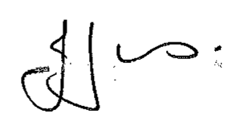

Julie Jones
Town Clerk

…………………………………………………………………………………………………………

AGENDA

1.ECG APOLOGIES

To receive apologies for absence.

2.ECG DISCLOSABLE INTERESTS
Members are reminded that they must not participate in the discussion or voting on any matter in which they have a Disclosable Pecuniary Interest and should leave the room prior to the commencement of the debate.

3.ECG LOCAL ECONOMIC GROWTH STRATEGY

To consider items for inclusion in the Market Drayton Economic Growth Strategy. (information attached)

Distribution: All members Membership: All Councillors

