Dear Members 20 October 2016

CHRISTMAS LIGHTS Sub Committee

You are hereby summoned to a meeting of the Christmas Lights Sub Committee at 6.30pm on Thursday 27 October 2016 in the Town Hall Chamber, Frogmore Road, Market Drayton.
AGENDA

16.212.CL APOLOGIES

To receive apologies for absence.

16.213.CL DISCLOSABLE PECUNIARY INTERESTS

Members are reminded that they must not participate in the discussion or voting on any matter in which they have a Disclosable Pecuniary Interest and should leave the room prior to the commencement of the debate.

16.214.CL MINUTES

To agree and confirm the minutes of a meeting of a Christmas Lights Sub Committee held on 29 September 2016. (Enclosed).

16.215.CL CHRISTMAS LIGHTS EVENT 2016

To consider the arrangements for the forthcoming event.

Yours faithfully

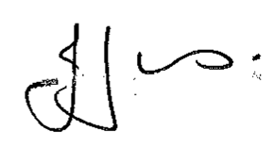

Julie Jones
Town Clerk

Membership: Cllrs R. Aldcroft, J. Beckett, T. Beckett, R. Hughes, L. Owen and L. Ridgway.

Distribution: All Councillors

