11 May 2018

To: All Members of Market Drayton Town Council

Dear Councillor

NOTICE IS HEREBY GIVEN that an Extraordinary Meeting of the above named Town Council will take place in the Council Chamber, Town Hall, Frogmore Road, Market Drayton on Thursday 17 May 2018 starting at 7.30 pm members are hereby summoned to attend for the purpose of transacting the following business.

The meeting is open to the press and public.

Councillor Mark Whittle ……………………………………..
Town Mayor

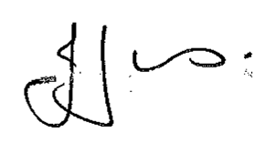
Julie Jones ……………………………………..
Town Clerk

AGENDA
1.EC Apologies

To receive apologies for absence.

2.EC Disclosable Pecuniary Interests

Members are reminded that they must not participate in the discussion or voting on any matter in which they have a Disclosable Pecuniary Interest and should leave the room prior to the commencement of the debate.

3.EC Neighbourhood Plan

Proposal:

To forward the submission draft Neighbourhood Plan document and associated documents to Shropshire Council under Regulation 15 of the neighbourhood plan regulations (see attached).

A hard copy of the plan is attached with this agenda. Other associated documents will be e mailed to members due to the volume of paper required. They will be available all week and at the meeting in hard copy if members wish to view them.

