21 April 2017

To: All Members of Market Drayton Town Council

Dear Councillor

NOTICE IS HEREBY GIVEN that an Extraordinary Meeting of the above named Town Council will take place in the Council Chamber, Town Hall, Frogmore Road, Market Drayton on Thursday 27 April 2017 starting at 7.15pm members are hereby summoned to attend for the purpose of transacting the following business.

The meeting is open to the press and public.

Councillor David Minnery
Town Mayor

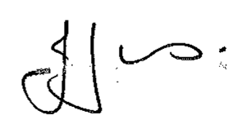
Julie Jones ……………………………………..
Town Clerk

AGENDA

1.EC Apologies

To receive apologies for absence.

2.EC Disclosable Pecuniary Interests

Members are reminded that they must not participate in the discussion or voting on any matter in which they have a Disclosable Pecuniary Interest and should leave the room prior to the commencement of the debate.

3.EC Neighbourhood Plan

To Resolve:

To submit the Market Drayton Neighbourhood Plan 2016-2026 to the Department of Communities and Local Government for a pre regulation 16 healthcheck.

Please find the NP attached

Distribution:
All Members
Press
Library

