8 June 2018

To: All Members of Market Drayton Town Council

Dear Councillor

NOTICE IS HEREBY GIVEN that an Extraordinary Meeting of the above named Town Council will take place in the Council Chamber, Town Hall, Frogmore Road, Market Drayton on Thursday 14 June 2018 starting at 7.30 pm members are hereby summoned to attend for the purpose of transacting the following business.

The meeting is open to the press and public.

Councillor Mark Whittle ……………………………………..
Town Mayor

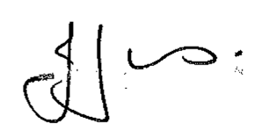
Julie Jones ……………………………………..
Town Clerk

AGENDA
1.EC Apologies

To receive apologies for absence.

2.EC Disclosable Pecuniary Interests

Members are reminded that they must not participate in the discussion or voting on any matter in which they have a Disclosable Pecuniary Interest and should leave the room prior to the commencement of the debate.

3.EC Exclusion of Press and Public

That in view of the confidential nature of the business about to be transacted which will involve the likely disclosure of exempt information relating to establishment and contractual matters as defined in Part 1 of Schedule12a Local Government Act 1972 and pursuant to the provisions of the Public Bodies (Admissions to Meetings) Act 1960 the public and press be temporarily excluded from the meeting and they are instructed to withdraw.

4.EC Insurance issues

To hear an update from the Clerk on a pre-action protocol.

5.EC Complaint

To consider a complaint.

Due to the confidential nature of the business on this agenda all information and correspondence will be distributed and collected back in on the night.

