13 June 2019

To: All Members of Market Drayton Town Council

Dear Councillor

NOTICE IS HEREBY GIVEN that an Extraordinary Meeting of the above named Town Council will take place in the Council Chamber, Town Hall, Frogmore Road, Market Drayton on Wednesday 19 June 2019 starting at 6.30 pm members are hereby summoned to attend for the purpose of transacting the following business.

The meeting is open to the press and public.

Councillor Roger Smith ……………………………………..
Town Mayor

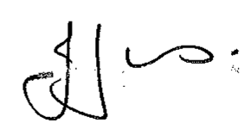
Julie Jones ……………………………………..
Town Clerk

AGENDA
1.EC APOLOGIES

To receive apologies for absence.

2.EC DISCLOSABLE PECUNIARY INTERESTS

Members are reminded that they must not participate in the discussion or voting on any matter in which they have a Disclosable Pecuniary Interest and should leave the room prior to the commencement of the debate.

3.EC INTERNAL AUDIT REPORT 2018/19

To agree and approve the end of year internal audit report 2018/19.

(previously circulated)

4.EC ANNUAL GOVERNANCE STATEMENT 2018/19

To review and approve the Annual Governance Statement 2018/19.

(Appendix CO14).

5.EC ACCOUNTING STATEMENTS 2018/19

To approve the Accounting Statement 2018/19 on the Annual Return.

(Appendix CO15).

