22 June 2018

To: All Members of Market Drayton Town Council

Dear Councillor

NOTICE IS HEREBY GIVEN that an Extraordinary Meeting of the above named Town Council will take place in the Council Chamber, Town Hall, Frogmore Road, Market Drayton on Thursday 28 June 2018 starting at 7.00 pm members are hereby summoned to attend for the purpose of transacting the following business.

The meeting is open to the press and public.

Councillor Mark Whittle ……………………………………..
Town Mayor

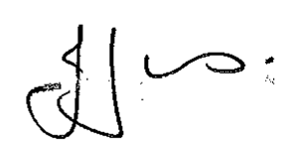
Julie Jones ……………………………………..
Town Clerk

AGENDA
1.EC APOLOGIES

To receive apologies for absence.

2.EC DISCLOSABLE PECUNIARY INTERESTS

Members are reminded that they must not participate in the discussion or voting on any matter in which they have a Disclosable Pecuniary Interest and should leave the room prior to the commencement of the debate.

3.EC INTERNAL AUDIT REPORT 2017/18

To agree and approve the end of year internal audit report 2017/18.

(Attached).

4.EC ANNUAL GOVERNANCE STATEMENT 2017/18

To approve the Annual Governance Statement 2017/18.

(Attached).

5.EC ACCOUNTING STATEMENTS 2017/18

To approve the Accounting Statement 2017/18 on the Annual Return.

(Attached).

