Date: 1 October 2021

To: All Members of Market Drayton Town Council
Councillor R. Aldcroft (Mayor), Councillor M. Whittle (Deputy Mayor).

Dear Councillor,

You are hereby summoned to attend an Extraordinary Market Drayton Town Council Meeting to be held in the Council Chamber, Town Hall, Frogmore Road, Market Drayton on Thursday 7 October 2021 starting at 7.10 pm.

The meeting is open to the Press and Public.

Members of the press and public can also listen to the meeting by right clicking on the link below, then opening the hyperlink. When the link opens, if you do not have Microsoft teams click on ‘watch on web’ then click on ‘join anonymously’.

https://bit.ly/3o8gbhz

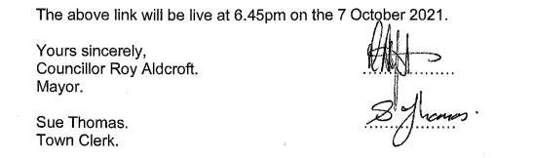

The meeting will be recorded and live streamed.

AGENDA

1.C APOLOGIES

To receive apologies for absence.

2.C DISCLOSABLE PECUNIARY INTERESTS

Members are reminded that they must not participate in the discussion or voting on any matter in which they have a Disclosable Pecuniary Interest and should leave the room prior to the commencement of the debate.

3.C EXTERNAL AUDIT 2020/21

To agree and approve the External Auditor Report and Certificate 2020/21.

See Appendix CO55 (Enclosed).

