Date: 21 July 2023

To: All members
Councillor Nellins (Chairman), Councillor Sanderson (Vice Chairman)

Dear Councillor

You are hereby summoned to attend an extraordinary meeting of the Community and Governance Committee to be held in the Council Chamber, Town Hall, Frogmore Road, Market Drayton on Thursday 27 July 2023 starting at 8.00pm or immediately following the Services and Facilities meeting.

The meeting is open to the Press and Public.

Members of the press and public can also listen to the meeting by right clicking on the link below, then opening the hyperlink. When the link opens, if you do not have Microsoft teams click on ‘watch on web’ then click on ‘join anonymously’

https://rb.gy/06psd

The link will be active from 6.45pm on the evening of the 29 June 2023.

Yours faithfully
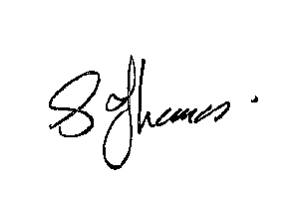
Sue Thomas
Town Clerk
The meeting will be recorded and live streamed.
…………………………………………………………………………………………………………

AGENDA
1.CG APOLOGIES

To receive apologies for absence.

2.CG DISCLOSABLE INTERESTS

i. To receive any disclosure of pecuniary interest - Members are reminded that they must not participate in the discussion or voting on any matter in which they have a Disclosable Pecuniary Interest and should leave the room prior to the commencement of the debate.

ii. To consider any applications for Dispensations under s33 of the Localism Act
2011.

3.CG SATURDAY BUS SERVICE (IN)

To consider subsidising a trial initiative to provide free travel for passengers on the Saturday town bus service. See Appendix CG48.

4.CG THREE PARISHES NEIGHBOURHOOD PLAN - STATUTORY (REG 16) CONSULTATION

To consider and respond to the Three Parishes Neighbourhood Plan – Statutory (Reg 16) Consultation. See Appendix CG49.

