Date: 15 March 2024

To: All members
Councillor R. Hughes (Chairman), Councillor T. Manton (Vice Chairman)

Dear Councillor

You are hereby summoned to attend a meeting of an Extraordinary Finance and General Purposes Committee to be held in the Council Chamber, Town Hall, 18 Frogmore Road, Market Drayton on Thursday 21 March 2024 starting at 7.15 pm.

The meeting is open to the Press and Public.

Members of the press and public can also listen to the meeting by right clicking on the link below, then opening the hyperlink. When the link opens, if you do not have Microsoft teams click on ‘watch on web’ then click on ‘join anonymously.’

https://shorturl.at/rzAM3

The link will be active from 6.45pm on the evening of 21 March 2024.

Yours sincerely
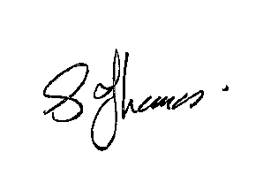

Sue Thomas

Town Clerk
The meeting will be recorded and live streamed.
AGENDA

1.FG APOLOGIES

To receive apologies for absence.

2.FG DISCLOSABLE PECUNIARY INTERESTS

i. To receive any disclosable Interests - Members are reminded that they must not participate in the discussion or voting on any matter in which they have a Disclosable Pecuniary Interest and should leave the room prior to the commencement of the debate.
ii. To consider any applications for Dispensations under s33 of the Localism Act 2011.

3.FG EARMARKED RESERVES

To consider the Earmarked Reserves for the financial year 2024/25.

See Appendix FG161 Current Earmarked Reserves as of 13 March 2024.

See Appendix FG162 Proposed Earmarked Reserves for 2024/25.

