Date: 6 June 2025

To: All Members of Market Drayton Town Council
(Councillor Manton (Mayor), Councillor Glover (Deputy Mayor)

Dear Councillor

You are hereby summoned to attend an Extraordinary Market Drayton Town Council Meeting to be held at 7.00pm on Thursday 12 June 2025 in the Council Chamber, 18 Frogmore Road, Market Drayton.
The meeting is open to the Press and Public.

Members of the press and public can also listen to the meeting by right clicking on the link below, then opening the hyperlink. When the link opens, if you do not have Microsoft teams click on ‘watch on web’ then click on ‘join anonymously’.

https://tinyurl.com/5dexvzj5

The link will be active from 6.45 pm on the evening of the 12 June 2025.
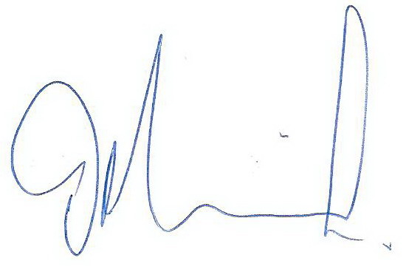
Yours faithfully

Councillor Tim Manton ………………………..
Mayor
Sue Thomas 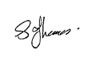
Town Clerk …………………………..

The meeting will be recorded and live streamed.
______________________________________________________________

A G E N D A

1.C APOLOGIES

To receive any apologies for absence.

2.C DISCLOSABLE INTERESTS

- To receive any disclosure of pecuniary interest - Members are reminded that they must not participate in the discussion or voting on any matter in which they have a Disclosable Pecuniary Interest and should leave the room prior to the commencement of the debate.

ii. To consider any applications for Dispensations under s33 of the Localism Act 2011.

3.C EXCLUSION OF PUBLIC PRESS

To resolve: that in view of the confidential nature of the business about to be transacted which will involve the likely disclosure of exempt information relating to establishment and contractual matters as defined in Part 1 of Schedule 12A, Local Government Act 1972, and pursuant to the provisions of the Public Bodies (Admissions to Meetings) Act 1960, the public and press be temporarily excluded from the meeting, and they are instructed to withdraw.

4.C COUNCILLOR CO-OPTION

To receive written applications for the office of Town Councillor and to Co-opt a
candidate to fill the current vacancy. See Appendix CO26 (attached).

The successful candidate to sign their declaration of acceptance of office.

Market Drayton Town Council

Extra-ordinary Council Meeting 12 June 2025

Private and Confidential Session

The Meeting will Resume Shortly

