Date: 8 August 2025

To: All Members
Councillor Tim Manton (Chairman)

Dear Councillor

You are hereby summoned to attend an extraordinary Market Drayton Council Meeting to be held in the Council Chamber, Town Hall, Frogmore Road, Market Drayton on Thursday 14 August 2025 starting at 7.30pm.

The meeting is open to the Press and Public.

Members of the press and public can also listen to the meeting by right clicking on the link below, then opening the hyperlink. When the link opens, if you do not have Microsoft teams click on ‘watch on web’ then click on ‘join anonymously’.

https://tinyurl.com/2v7t6tbx

The link will be active from 7.00pm on the evening of the 14 August 2025.

Yours sincerely
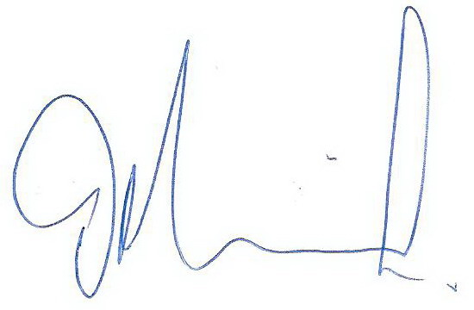
Tim Manton
Mayor
The meeting will be recorded and live streamed

AGENDA

1.C APOLOGIES

To receive apologies for absence.

2.C DISCLOSABLE INTERESTS

i. To receive any disclosable interests. Members are reminded that they must not participate in the discussion or voting on any matter in which they have a Disclosable Pecuniary Interest and should leave the room prior to the commencement of the debate.

ii. To consider any applications for Dispensations under s33 of the Localism Act 2011.

3.C PUBLIC SESSION

Members of the public are invited to question the Council/Committee on local issues, provided they indicate their intention to do so to the Town Clerk by NOON on the day before the meeting.

Questions may be answered during this session or deferred for further advice. The Chairman will select the order of the matters to be heard. Each speaker will be limited to a period of three minutes (to a maximum of 15 minutes total public session at the Chairman’s discretion).

Standing Orders will be suspended for fifteen minutes during the public session.

4.C PLAY AREAS

- To receive an update on works undertaken and proposed work on the play areas. See Appendix C067
- To consider and agree what action to take regarding the slide unit on Longlands play area
- To consider the recommendation from the working group to replace the two rockers on the town park.
- To consider exploring the option of extending the town park play area.
- To discuss the ongoing ASB on Longlands play area.

5.C CHRISTMAS LIGHTS

To consider purchasing new lights for Christmas 2025. See Appendix C068.

6.C COUNCIL COMPUTERS

- To receive the notes from the Laptop Working Group and to consider the recommendations from the working group. See Appendix C069.

7.C LOCAL GOVERNMENT SERVICES PAY AGREEMENT 2025/26

The National Joint Council for Local Government Services (NJC) has reached an agreement on rates of pay applicable from 1 April 2025 to 31 March 2026; an increase of 3.2% has been awarded. See Appendix C070.

To Note the increase

8.C TOWERS LAWN TOILETS

- To consider the recommendation from the Towers Lawn Toilet working group for the upgrade of the toilets, including the provision of a drivers rest room. C071.
- To give the working group delegated powers to agree the Building Contract.

9.C CORRESPONDANCE

To consider the following correspondence from Councillor Helen Kidd. See Appendix C072.

