30 August 2024

To: All Members of Market Drayton Town Council
(Councillor Aldcroft (Mayor), Councillor Manton (Deputy Mayor)

Dear Councillor

You are hereby summoned to attend an Extraordinary Market Drayton Town Council Meeting to be held at 7.25 pm on Thursday 5 September 2024 or immediately following the Planning Committee in the Council Chamber, 18 Frogmore Road, Market Drayton.
The meeting is open to the Press and Public.

Members of the press and public can also listen to the meeting by right clicking on the link below, then opening the hyperlink. When the link opens, if you do not have Microsoft teams click on ‘watch on web’ then click on ‘join anonymously’.

https://shorturl.at/AQr8X

The link will be active from 6.45 pm on the evening of the 5 September 2024.

Yours faithfully
Councillor Aldcroft 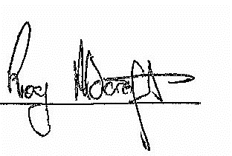
Town Mayor …………………………...

Sue Thomas 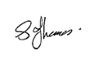
Town Clerk …………………………..

The meeting will be recorded and live streamed in line with the Recording of Public Meetings Policy

A G E N D A

1.C APOLOGIES

To receive any apologies for absence.

2.C DISCLOSABLE PECUNIARY INTERESTS

- Members are reminded that they must not participate in the discussion or
voting on any matter in which they have a Disclosable Pecuniary Interest and
should leave the room prior to the commencement of the debate.
- To consider any applications for Dispensations under s33 of the Localism Act
2011.

3.C EXTERNAL AUDITOR’S REPORT AND CERTIFICATE 2023/24

- To agree and approve the External Auditor’s Report and Certificate 2023/2024.
See Appendix CO56.

- It is a strategy requirement to publish the Notice of conclusion of audit along
with the certified Annual Governance and Accountability Return.

To agree a length of time the notice is to be published. The previous statute required 14 days; but it is now up to the authority how long to publish the notice.

See Appendix CO57.

