Date: 8 August 2025

To: All members of Market Drayton Town Council
Councillor Glover (Chairman), Councillor Hughes (Vice Chairman)

Dear Councillor,

You are hereby summoned to attend an extraordinary meeting of the Planning Committee to be held in the Council Chamber, Town Hall, 18 Frogmore Road, Market Drayton on Thursday 14 August 2025 starting at 7.15pm.

The meeting is open to the Press and Public.

Members of the press and public can also listen to the meeting by right clicking on the link below, then opening the hyperlink. When the link opens, if you do not have Microsoft teams click on ‘watch on web’ then click on ‘join anonymously.

https://tinyurl.com/2v7t6tbx

The link will be active from 7.00 pm on the evening of 14 August 2025.

Yours sincerely
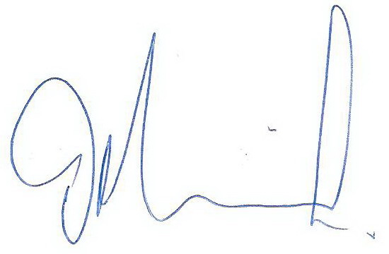

Tim Manton

Mayor

The meeting will be recorded and live streamed

AGENDA

1.PL APOLOGIES

To receive apologies for absence.

2.PL DISCLOSABLE PECUNIARY INTERESTS

i. To receive any disclosable Interests - Members are reminded that they must not participate in the discussion or voting on any matter in which they have a Disclosable Pecuniary Interest and should leave the room prior to the commencement of the debate.
ii. To consider any applications for Dispensations under s33 of the Localism Act 2011.

3.PL PUBLIC SESSION

Members of the public are invited to question the Council/Committee on local issues, provided they indicate their intention to do so to the Town Clerk by NOON on the day before the meeting.

Questions may be answered during this session or deferred for further advice. The Chairman will select the order of the matters to be heard. Each speaker will be limited to a period of three minutes (to a maximum of 15 minutes total public session at the Chairman’s discretion).

Standing Orders will be suspended for fifteen minutes during the public session.

4.PL PLANNING APPLICATIONS

Reference: 25/02547/FUL (validated: 31/07/2025)
Address: Land Off Greenfields Lane, Market Drayton, Shropshire
Proposal: Erection of 22 dwellings and associated landscaping and Infrastructure.
Applicant: Tilia Homes (C/o Agent)

View online at: http://pa.shropshire.gov.uk/online-applications/applicationDetails.do?activeTab=summary&keyVal=SZ3EHPTDJ6W00
…………………………………………………………………………………………………

Reference: 25/02649/FUL (validated: 25/07/2025)
Address: 6 Milton Drive, Market Drayton, Shropshire, TF9 3SP
Proposal: Proposed single storey rear extension, to replace existing conservatory
Applicant: Mr and Mrs Ian and Debbie Branch

View online at: http://pa.shropshire.gov.uk/online-applications/applicationDetails.do?activeTab=summary&keyVal=SZK265TDJE200
……………………………………………………………………………………………….

