23 September 2022

To: All Members of Market Drayton Town Council
(Councillor Whittle (Mayor), Councillor T Beckett (Deputy Mayor)

Dear Councillor

You are hereby summoned to attend an Extraordinary Market Drayton Town Council Meeting to be held at 7.00 pm on Thursday 29 September 2022 in the Council Chamber, 18 Frogmore Road, Market Drayton.
The meeting is open to the Press and Public.

Members of the press and public can also listen to the meeting by right clicking on the link below, then opening the hyperlink. When the link opens, if you do not have Microsoft teams click on ‘watch on web’ then click on ‘join anonymously’.

https://bit.ly/3LsK2e4

The link will be active from 6.45 pm on the evening of the 29 September 2022.

Yours faithfully
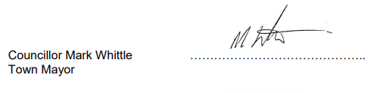
Sue Thomas 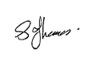
Town Clerk …………………………..

The meeting will be recorded and live streamed

A G E N D A

1.C APOLOGIES

To receive any apologies for absence.

2.C DISCLOSABLE PECUNIARY INTERESTS

Members are reminded that they must not participate in the discussion or voting on any matter in which they have a Disclosable Pecuniary Interest and should leave the room prior to the commencement of the debate.

3.C EXTERNAL AUDIT REPORRT AND CERTIFICATE 2021/22

- To agree and approve the External Auditor Report and Certificate 2021/2022.
See Appendix C53.

- It is a strategy requirement to publish the Notice of conclusion of audit along
with the certified Annual Governance and Accountability Return.

To agree a length of time the notice is to be published. The previous statute required 14 days; but it is now up to the authority how long to publish the notice.

See Appendix C54.

4.C DALELANDS PLAYPARK

- To receive a written update report on the levelling of the grassed mound.

See Appendix C55

- To consider a quote to turf the re-landscaped area.

See Appendix C56

