17 March 2023

To: All Members of Market Drayton Town Council
(Councillor Whittle (Mayor), Councillor T Beckett (Deputy Mayor)

Dear Councillor

You are hereby summoned to attend an Extraordinary Market Drayton Town Council Meeting to be held in the Council Chamber, 18 Frogmore Road, Market Drayton on Thursday 23rd March 2023 at 8.30pm or immediately following the Services and Facilities Committee Meeting.
The meeting is open to the Press and Public.

Members of the press and public can also listen to the meeting by right clicking on the link below, then opening the hyperlink. When the link opens, if you do not have Microsoft teams click on ‘watch on web’ then click on ‘join anonymously’.

https://bit.ly/3mxHuTv

The link will be active from 6.45pm on the evening of the 23 March 2023.

Yours faithfully
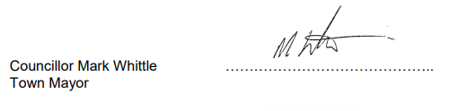
Sue Thomas 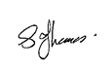
Town Clerk ……………….……………..

The meeting will be recorded and live streamed

A G E N D A

1.C APOLOGIES

To receive any apologies for absence.

2.C DISCLOSABLE PECUNIARY INTERESTS

i. To receive any disclosable interests - Members are reminded that they must not participate in the discussion or voting on any matter in which they have a Disclosable Pecuniary Interest and should leave the room prior to the commencement of the debate.

ii. To consider any applications for Dispensations under s33 of the Localism Act 2011.

3.C EXCLUSION OF PUBLIC PRESS

To resolve: that in view of the confidential nature of the business about to be transacted which will involve the likely disclosure of exempt information relating to establishment and contractual matters as defined in Part 1 of Schedule 12A, Local Government Act 1972, and pursuant to the provisions of the Public Bodies (Admissions to Meetings) Act 1960, the public and press be temporarily excluded from the meeting and they are instructed to withdraw.

4.C COMPLAINT

To discuss a complaint and consider what action to take.

