17 September 2020

To: All members of Market Drayton Town Council
Councillor M Whittle (Chairman), Councillor M. Smith (Vice Chairman)

Dear Member

NOTICE IS HEREBY GIVEN that an Extra-ordinary meeting of the Community and Governance Committee will take place at 7.15pm or immediately following the Planning Committee Meeting on Thursday 24 September 2020.

This is a virtual meeting.

Members of the public will be able to listen to the meeting by right clicking on the link below, then opening the hyperlink. When the link opens, if you do not have Microsoft teams click on ‘watch on web’ then click on ‘join anonymously’.

https://bit.ly/2G9Gdgb

The meeting is open to the Press and Public.

Yours faithfully

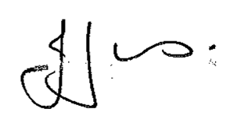

Julie Jones
Town Clerk
…………………………………………………………………………………………………………

AGENDA

1.CG APOLOGIES

To receive apologies for absence.

2.CG DISCLOSABLE INTERESTS

Members are reminded that they must not participate in the discussion or voting on any matter in which they have a Disclosable Pecuniary Interest and should leave the room prior to the commencement of the debate.

3.CG LOCAL PLAN REVIEW

Decision deferred from the Community and Governance meeting held on the 10th September, Agenda Item 6.CG.

To consider a final response to the Regulation 18 pre-submission Draft Local Plan Consultation.

- Local Plan Consultation Document. See Appendix CG20 in the Councillors electronic folder

- Clerks suggested amendments, agreed in principle, with additional suggestions. See Appendix CG25 (attached)

