Date: 19 July 2024

To: All members of Market Drayton Town Council
Councillor Sanderson (Chairman), Councillor Erwin (Vice Chairman)

Dear Councillor

You are hereby summoned to attend an Extraordinary meeting of the Community and Governance Committeeto be held in the Council Chamber, Town Hall, Frogmore Road, Market Drayton on Thursday 25 July 2024 starting at 7.15pm or immediately following the Planning Committee Meeting.

The meeting is open to the Press and Public.

Members of the press and public can also listen to the meeting by right clicking on the link below, then opening the hyperlink. When the link opens, if you do not have Microsoft teams click on ‘watch on web’ then click on ‘join anonymously’

https://tinyurl.com/bdfmxfxb

The link will be active from 6.45pm on the evening of the 25 July 2024.

Yours faithfully
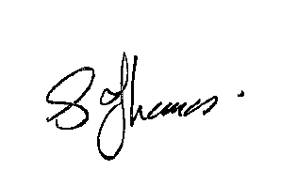
Sue Thomas
Town Clerk
The meeting will be recorded and live streamed.
…………………………………………………………………………………………………………

AGENDA
1.CG APOLOGIES

To receive apologies for absence.

2.CG DISCLOSABLE INTERESTS

i. To receive any disclosure of pecuniary interest - Members are reminded that they must not participate in the discussion or voting on any matter in which they have a Disclosable Pecuniary Interest and should leave the room prior to the commencement of the debate.

ii. To consider any applications for Dispensations under s33 of the Localism Act
2011.

3.CG CARPARKING CHARGES

To consider and respond to the Shropshire Council Carpark Charges 2024 consultation.

See Appendix CG047a attached.

