4 July 2025

To: Councillors: R. Aldcroft, J. Blandford, P. Glover, G. Groves (Chair), R. Hughes, and
I. Nellins.

Also: All Members of the Council for information only.

Dear Councillor

You are required to attend a meeting of the Personnel Committee to be held in the Town Hall Chamber, Frogmore Road, Market Drayton on 10 July 2025 starting at 8.30pm or immediately following the Council Meeting, whichever is the earliest.

Yours sincerely
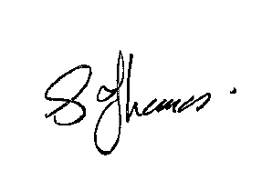
Sue Thomas
Town Clerk

PLEASE NOTE THAT ALL PERSONNEL MATTERS ARE CONFIDENTIAL BUSINESS

AGENDA

1.P APOLOGIES

To receive apologies for absence.

2.P DISCLOSURE PECUNIARY INTERESTS

i. To receive any disclosable Interests - Members are reminded that they must not
participate in the discussion or voting on any matter in which they have a
Disclosable Pecuniary Interest and should leave the room prior to the
commencement of the debate.

ii. To consider any applications for Dispensations under s33 of the Localism Act 2011.

3.P MINUTES

To agree and adopt the minutes of the meeting of the Personnel Committee held on 22 May 2025. See appendix P065.

4.P EXCLUSION OF PUBLIC PRESS

To resolve: That in view of the confidential nature of the business about to be transacted which will involve the likely disclosure of exempt information relating to establishment and contractual matters as defined in Part 1 of Schedule 12A, Local Government Act 1972, and pursuant to the provisions of the Public Bodies (Admissions to Meetings) Act 1960, the public and press be temporarily excluded from the meeting and they are instructed to withdraw.

5.P POSTHOLDER 33

To consider increasing post holder 33’s working hours from 20 per week to 24 per week.

