14 March 2025

To: Councillors: R. Aldcroft, M. Erwin, P. Glover, R. Hughes, W. Love, and I. Nellins.
Councillor Matt Erwin (Chairman)

Also: All Members of the Council for information only.

Dear Councillor

You are required to attend a meeting of the Personnel Committee to be held in the Town Hall Chamber, Frogmore Road, Market Drayton on 20 March 2025 starting at 8.00pm or immediately following the Finance and Governance Committee meeting.

Yours sincerely
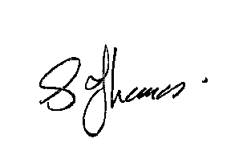
Sue Thomas
Town Clerk

PLEASE NOTE THAT ALL PERSONNEL MATTERS ARE CONFIDENTIAL BUSINESS

AGENDA

1.P APOLOGIES

To receive apologies for absence.

2.P DISCLOSURE PECUNIARY INTERESTS

i. To receive any disclosable Interests - Members are reminded that they must not
participate in the discussion or voting on any matter in which they have a
Disclosable Pecuniary Interest and should leave the room prior to the
commencement of the debate.

ii. To consider any applications for Dispensations under s33 of the Localism Act 2011.

3.P MINUTES

To agree and adopt the minutes of the meeting of the Personnel Committee held on 20 February 2025. See appendix P168.

4.P EXCLUSION OF PUBLIC PRESS

To resolve: That in view of the confidential nature of the business about to be transacted which will involve the likely disclosure of exempt information relating to establishment and contractual matters as defined in Part 1 of Schedule 12A, Local Government Act 1972, and pursuant to the provisions of the Public Bodies (Admissions to Meetings) Act 1960, the public and press be temporarily excluded from the meeting and they are instructed to withdraw.

5.P HR SUPPORT

To consider the quotes for HR support.

Quotes to follow.

