Please note there will be no Planning Meeting on Thursday 14 July 2016 as there are no applications, the Services and Facilities Committee Meeting with start at 7pm.

Julie Jones
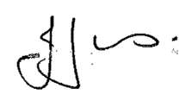
Town Clerk

