5 January 2018

To: All members
Councillor T Beckett (Chairman), Councillor J Cadwallader (Vice Chairman)

Dear Councillor

You are required to attend An Extraordinary meeting of the Finance & General Purposes Committee to be held in the Council Chamber, Town Hall, Frogmore Road, Market Drayton, on Thursday 11 January starting at 7.15 pm.

Yours sincerely

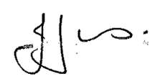

Julie Jones
Town Clerk

AGENDA

1.FG APOLOGIES

To receive apologies for absence.

2.FG DISCLOSABLE PECUNIARY INTERESTS

Members are reminded that they must not participate in the discussion or voting on any matter in which they have a Disclosable Pecuniary Interest and should leave the room prior to the commencement of the debate.

3.FG BUDGET FOR 2018/19

To agree a budget for the financial year 2018/19 for this committee (see enclosed)

