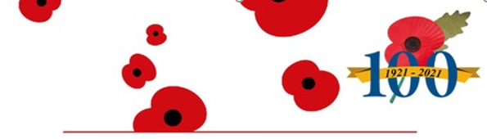



Market Drayton Town Council

**Remembrance Sunday 14 November 2021**

Market Drayton Town Council would like to invite all residents to watch the Remembrance Sunday Parade, and the service and wreath laying at the War Memorial on Sunday 14th November 2021.

The Remembrance Sunday Service at St Mary’s Church is subject to restrictions, therefore, due to limited capacity attendance to the Church service is by ticket only.

If you would like to attend the Church Service tickets can be collected from:

* Market Drayton Town Council Offices, Monday to Friday between 9am and 1pm
* The Royal British Legion every day from 6.30pm onwards.

Tickets will be allocated on a first come first served basis. Please note masks must be worn in Church.

The audio of the service will be relayed outside the Church for people who wish to listen and a live stream of the service will be on the St Marys Church Facebook page (StMarysMarketDrayton)

The timings for the event are as follows:

Parade to form at Queen Street Car Park 10.10 a.m.

Parade from Queen Street Car Park to Church 10.20 a.m.

Guests/Residents with tickets to be seated in Church 10.40 a.m.

Church Service 10.45 a.m.

End of Service 11.35 a.m.

Parade march from Church 11.45 a.m.

Salute by Nat West Bank 11.55 a.m.

Parade and War Memorial Service 12.00 noon.

**Note:** Wreath collection from 7pm – 9pm on Friday 12 November 2021 at Market Drayton Royal British Legion Club.

The rehearsals for standard bearers is on Friday 12 November, 7pm at St Mary’s Church.

**“We will remember them”**