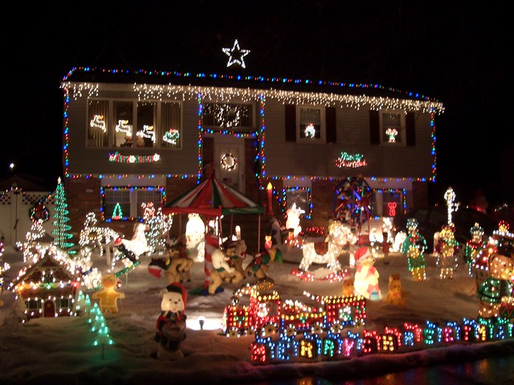

**.**

**Closing date for entries is**

**Wednesday 8th December 2021**

**Judging will take place week**

**commencing**

**13th December 2021**

**Return this form to :**

**Market Drayton Town Council, The Town Hall, 18 Frogmore Road, Market Drayton, TF9 3AX. Telephone: 01630 653364 email:admin@marketdrayton.gov.uk**

Shop Window Christmas Lights Competition 2021

Application Form

**Your details**

**Business/Shop Name:**

**Name:**

**Address:**

**Contact Number:**

**Light up Market Drayton**

**This Christmas**

**Town Council**

**Market Drayton**