Finance & General Purposes Committee Meeting | 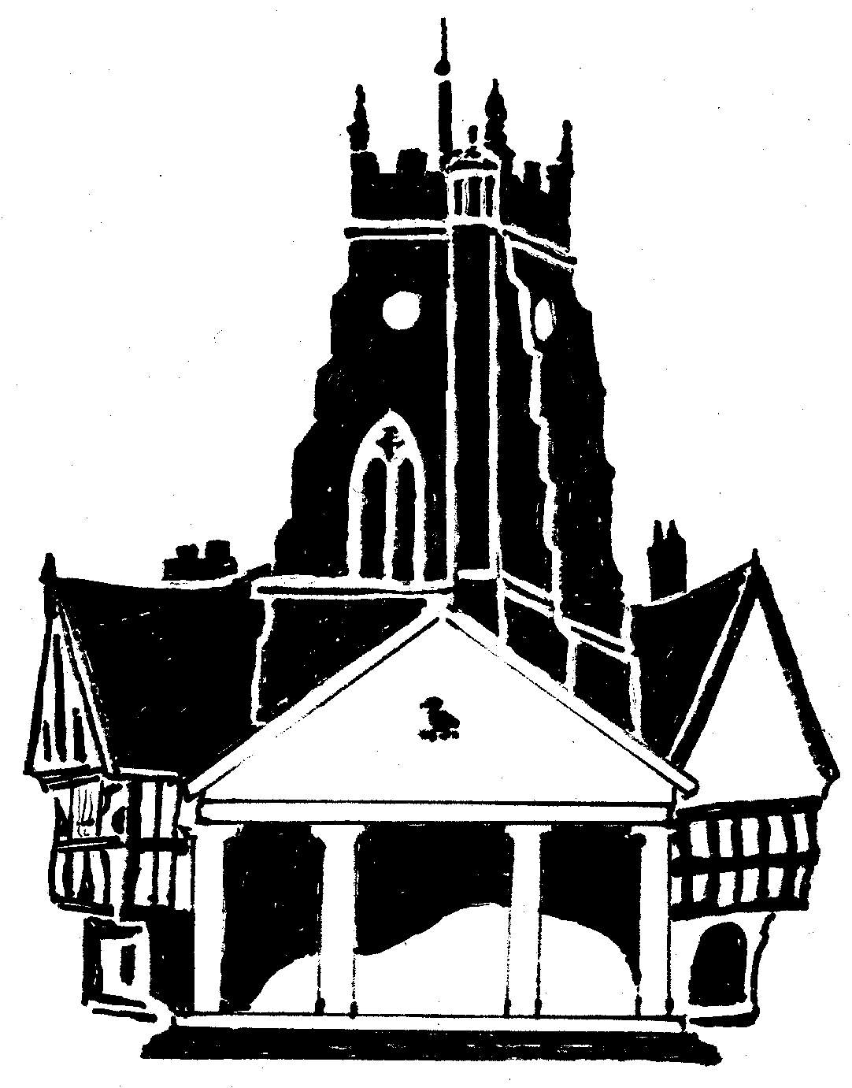  Market Drayton  Town Council
Agenda Item: 5.FG – Large Grants

Date: 16 June 2022

Appendix : FG 19

Organisation | Request  Amount | To Fund | Suggested  Funding  (Chair, Vice Chair, Clerk) | Funded in 2021/22
Market Drayton Arts Festival (MDCE) | £3,000 | Room & site hire and advertising events (purchase of banners, leaflets etc) | £1,500 | £300  8 July 2021
Walkmill Meadows and Marsh Working Group (MDCE) | £5,000 | Spring bulbs, bird boxes, owl boxes, easels, paints, paper etc to allow artistic events to be arranged & improvement work | £2,000 | £0
Market Drayton Town Football Club | £5,000 | New lighting bulbs for the existing floodlights to transfer them from metal halide systems to LED | Consider allocating funding out of EM Reserves | £0
Ashley & Loggerheads First Responders | £5,000 | Towards cost of a vehicle | £1,000 | £0
Market Drayton Carnival  (Market Drayton Traders CIC) | £5,000 | Costs of putting on the event, event insurance, safety equipment, crowd barriers, hire of sound equipment. | £1,500 | £300  10 Feb 2022
Market Drayton Mencap Club | £2,322 | New lightweight tables | £0 | £300  10 Feb 2022
Ginger & Spice Festival | £3,449 | Health & Safety, New look food theatre, and costs of staging the event | £1,500 | £1,500  8 July 2021
Citizens Advice Shropshire | £4,464 | Costs of running the service | £4,464 | £3,000  8 July 2021
Total | £33,235 |  | £11,964 (excluding MD Football Club)

