Finance & General Purposes Committee Meeting | 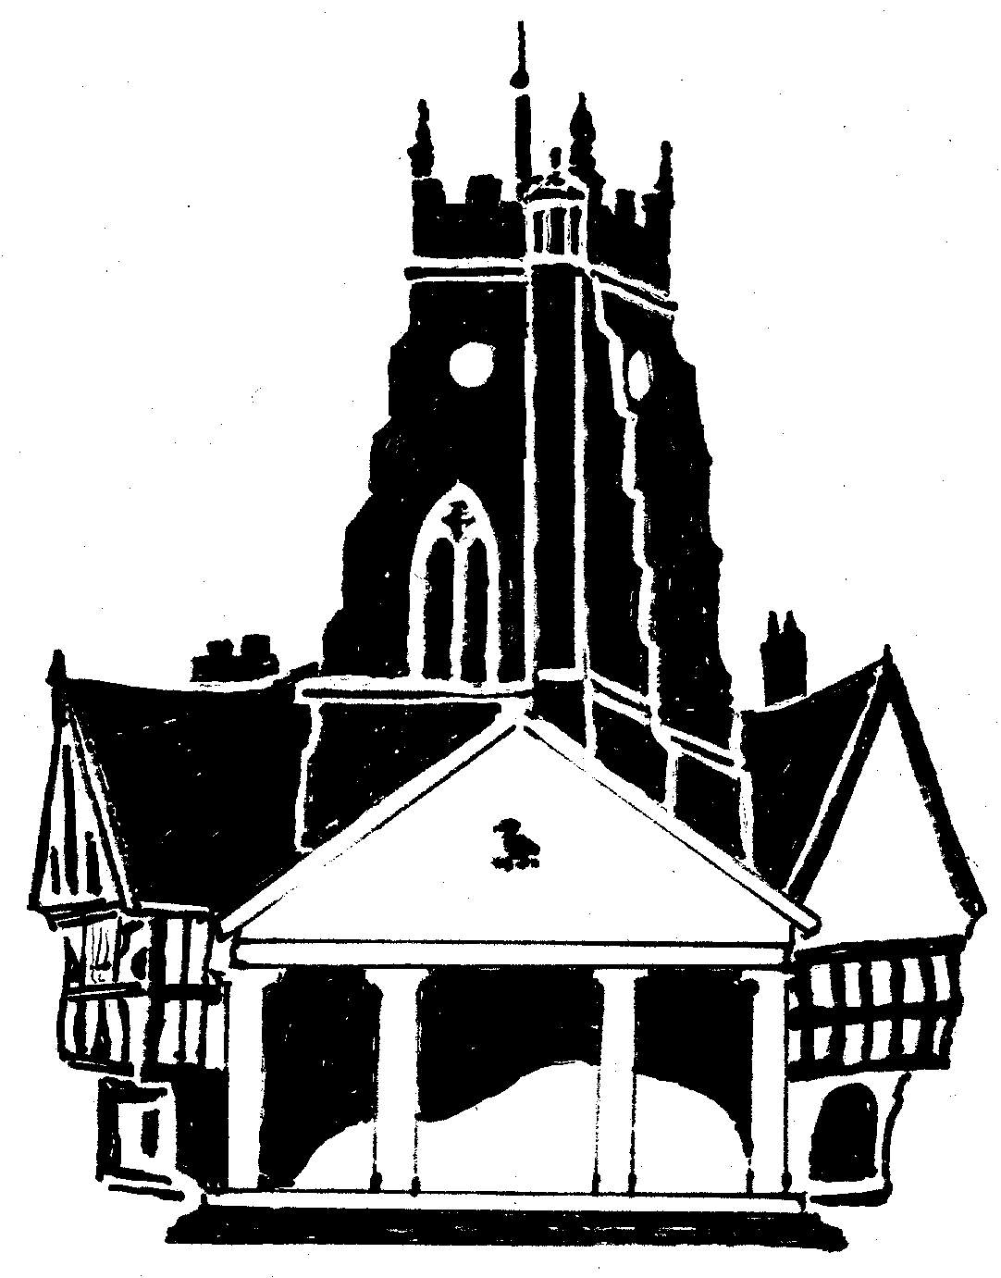  Market Drayton  Town Council
Agenda Item: 5.FG – Small Grants

Date: 16 June 2022

Appendix : FG 18

Organisation | Requested Amount  £ | To Fund | Funded in 2021/22
MDCE | £300 | Venue hire for Hosting three festivals in 2022 | £300  19 August 2021
Market Drayton Men’s Shed | £300 | Towards electrical bills and running costs | £0
Market Drayton Methodist Church | £300 | Running costs and decals of artwork on the double decker bus | £300  19 August 2021
Market Drayton Community Car | £300 | Running costs | £0
Age UK Day Centre | £300 | Running costs | £300  8 July 2021
Dig4Veterans | £300 | Tools, storage, wood, equipment, and seeds | £300  22 April 2021
East Shropshire Talking Newspaper for visually impaired | £300 | Venue hire costs (28 people receive memory sticks of recordings within the town) | £0
Total | £2,100

