Finance & General Purposes Committee Meeting | 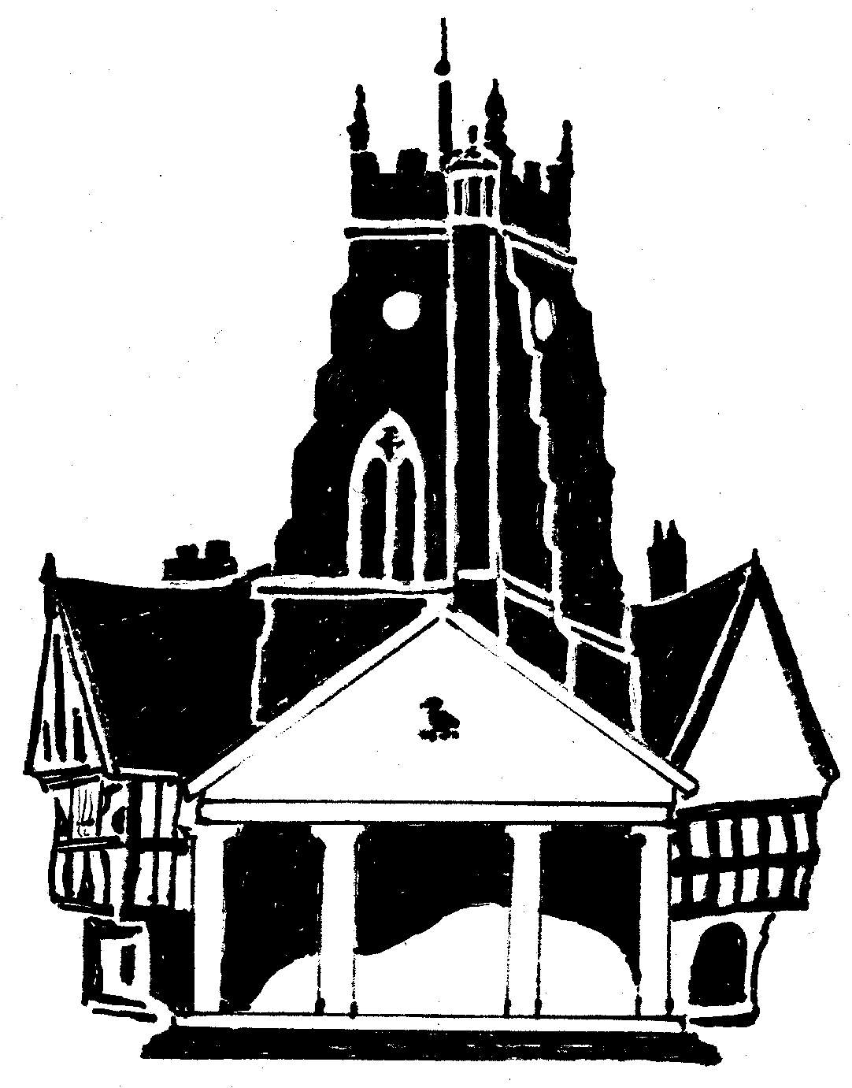  Market Drayton  Town Council
Agenda Item: 6.FG – Town Hall i

Date: 1 September 2022

Appendix : FG50

Quote Reference | Amount Quoted £
A | £595.00
B | £885.00
C | £720.00 (Around)

Please note all three quotes are from local traders.

