Community and Governance Committee Meeting | 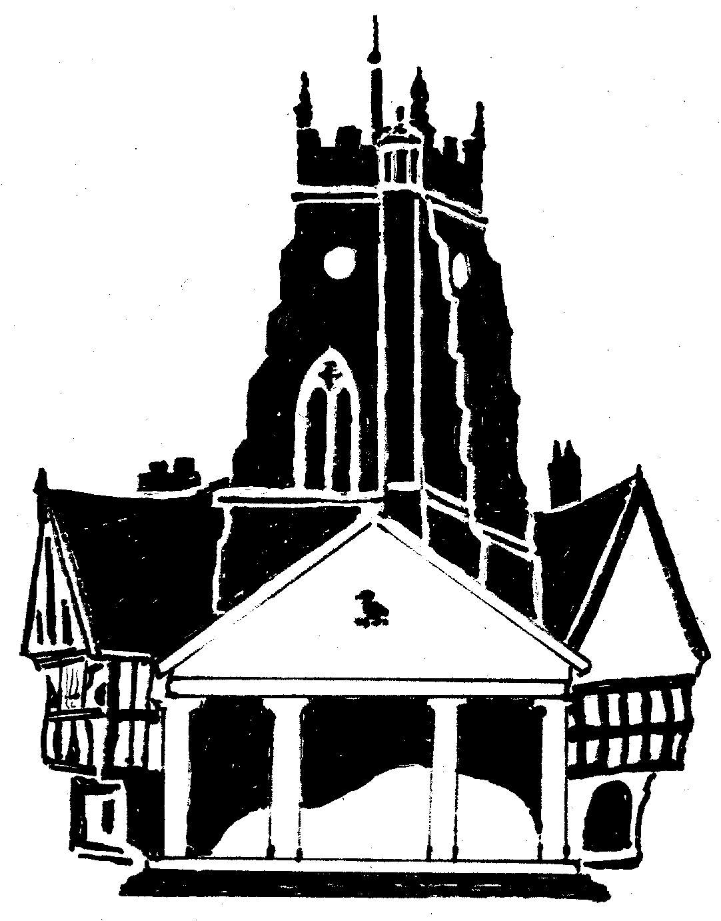  Market Drayton  Town Council
Agenda Item: 6.CG Draft Community and Governance Budget

Date: 10 November 2022

Appendix : CG85

Cost Centre 301 | Description | Budget  2022/23 | Proposed 2023/24
4323 | Community & Governance | 5,000 | 5,000
4325 | Drayton Messenger | 7,000 | 7,000
4326 | Events | 0 | 0
4017 | Police Panel | 2,500 | 1,500
4326 | Citizens Advice Bureau | 0 | 3,000 | This funding has been moved from the large grants/events budget.
Total |  | 14,500 | 16,500

