Services and Facilities Committee Meeting | 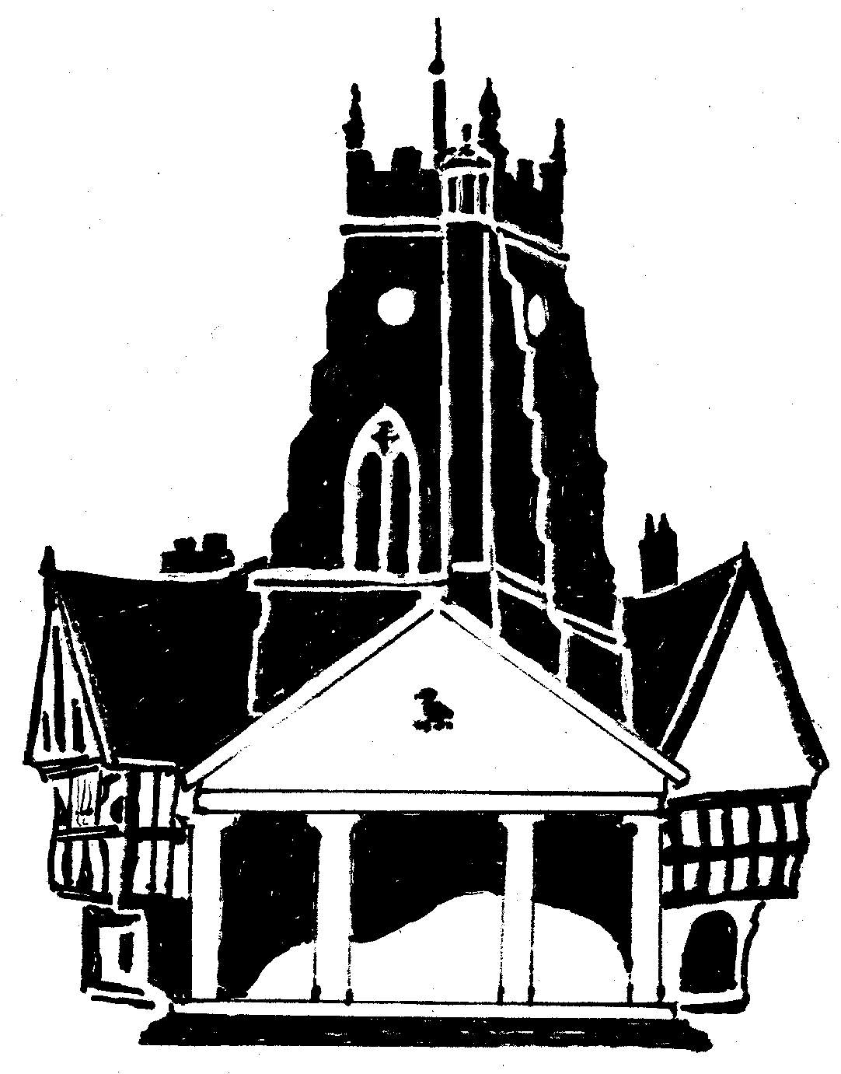  Market Drayton  Town Council
Agenda Item: 11.SF Draft Budget

Date: 24 November 2022

Appendix : SF92

Cost Centre | Description | Budget 2022/23 | Proposed Budget 2023/24 | Draft Budget 2023/24 agreed at the meeting
101 | Street Lighting | 19,800 | 16,000 |  | By joining Shropshire Councils scheme for streetlights, we anticipate that we will be able to save money on street lighting electricity.
103 | Recreation Grounds | 66,220 | 78,220 |  | This includes an increase in funding for Greenfields from £27,500 to £40,000.
104 | Amenity Areas | 6,750 | 4,500
105 | CCTV running costs | 2,060 | 2,060
107 | In Bloom | 7,500 | 7,000 |  | Includes £6,000 for floral displays
111 | Cemetery | 40,822 | 40,315 |  | An increase in utilities of £3,080 has been offset by a decrease in the general maintenance budget.
112 | Public Toilets | 24,800 | 26,600 |  | An increase in utilities of £1,300
113 | Christmas Lighting | 15,075 | 16,150 |  | £1,000 increase to cover the additional stall hire charge
150 | Services & Facilities (General) | 150,300 | 165,000 |  | Increase in salaries for 2022/23 agreed in November, back dated to April 2022 and budgeting for an increase in 2023/24. Increase in diesel costs.  Includes £19,400 for youth provision.
Total |  | 333,327 | 355845 |  | An increase of £22,518

