The Three Parishes of Adderley, Norton in Hales and Moreton Say
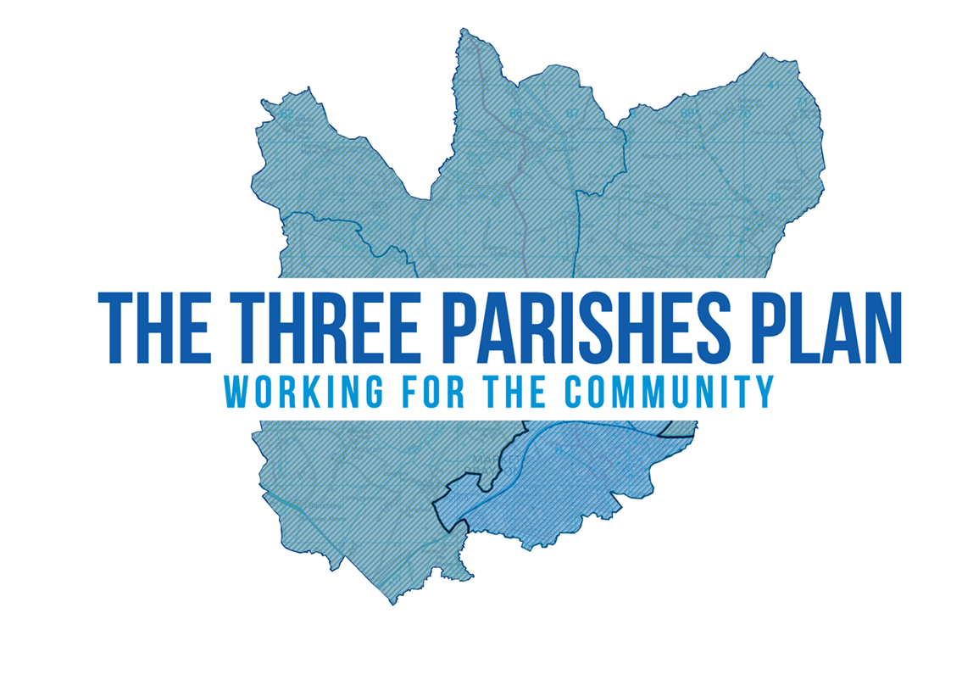

Regulation 14 Submission
Consultation Document

Introduction
The Three Parishes of Adderley, Norton-In-Hales and Moreton Say are registered under the Shropshire Local Plan as a ‘Community Cluster’ which consist of settlements with aspirations to maintain or enhance their sustainability through modest levels of appropriate development.
The Three Parishes hold a responsibility for their historic and environmental heritage, and as part of this Neighbourhood Plan we are seeking to ensure the continued protection of our Neighbourhood area.
There is a shared commitment to ‘future proof’ the land for future diversification of industry, amenity areas and tourism; to maximise the potential of our land and capture the vitality and vibrancy of the rural areas.
The aim of this Neighbourhood Plan is to recognise the potential for economic growth in Shropshire whilst ensuring that the Three Parishes have a role in that future.
The purpose of this summary document is to outline the policies that are contained within the Three Parishes Neighbourhood Plan whilst additional information outlining the context of the neighbourhood area and procedures to make the Three Parishes Neighbourhood Plan contained within the full Regulation 14 (Pre-Submission) document.
How to comment
The draft plan can be inspected on the Parish website: https://threeparishplan.org/ or be emailed to residents and others interested parties on request.
Paper copies of the plan can be viewed at the following:
- Bus Shelter, Main Road, Norton in Hales, Shropshire TF9 4AT;
- Bus Shelter Library, Rectory Lane, Adderley, Market Drayton, Shropshire, TF9 3TL; and
- Notice Board on Moreton Say Village Hall, Moreton Say, Shropshire, TF9 3RS.
The Draft Plan and accompanying reports can also be viewed on the Shropshire Council website: https://shropshire.gov.uk/planning-policy/neighbourhood-and-community-led-plans/emerging-neighbourhood-plans/.
Please note that all comments must be sent to the Secretary to the Steering Group (not to Shropshire Council):
Comments can be posted to:
Secretary to the Steering Group Mrs Jane Evans, 51 Longford Turning, Market Drayton, Shropshire, TF9 3PF.
Or put in the Comment Collection Boxes, location details are on the Consultation Response Form
Or emailed to: clerk@adderleyparish.co.uk
Or alternatively submit your comments directly on-line at threeparishplan.org

All comments to be received by 5:00pm on Monday 9th January 2023 at the latest.

Policies
The following policies were devised to reflect the opinions of the Three Parishes, guiding and influencing new developments that maintain the Parish’s attractive and historic character. These policies will look to help decisions be made about new development through the planning application process.
Once adopted policies within the Three Parishes Neighbourhood Plan will be considered alongside the National Planning Policy Framework and the Shropshire Local Plan when planning decisions are made to either dismiss or approve within our area.
The policies are listed below for ease of reference.
- Housing and Design
- H1 Housing Design
- H2 Housing Mix and Tenure

- Employment and Business
- EMP1 Small Scale Employment
- EMP2 Farm Diversification

- Natural Environment
- G1 Protecting Open Spaces in the Three Parishes
- G2 Protection and Enhancement of Biodiversity
- G3 Carbon Reduction

- Movement and Connection
- T1 Linkages and Connections
- T2 Parking
- T3 Connecting the Parishes

- Built Environment and Heritage
- LE1 Conservation of the Three Parishes Historic Character

- Community Facilities
- COM1 Community Facilities

A. Housing and Design Policy
H1 Housing Design
Development proposals within the Neighbourhood Area that demonstrate high quality design and contribute to the beauty and sustainability of the built environment will be supported where they have regard to the following:
- Do not adversely affect the local characteristics and setting of their surroundings, keeping with the scale and character of buildings and the layout of the area;
- Maintain visual amenity of the Parishes providing high quality boundary treatment that is appropriate to maintaining the rural character;
- Minimise adverse impacts on the amenity of future or adjacent property by reason of overshadowing, overlooking, visual intrusion, noise and disturbance and odour;
- Complements the existing materials seen locally, with particular consideration for window design, doorways and chimneys;
- Provide good pedestrian and cycle connections to existing travel routes;
- Provide adequate storage for bins and recycling;
- Incorporates Secured by Design standards where it is reasonable to do so;
- Support features beneficial to wildlife and biodiversity where appropriate;
- Delivers energy efficient and environmentally friendly measures such as the installation of solar panels or heat pumps; rainwater porous driveways and parking areas; including proactive measures to reduce CO2 emissions; and
- Traffic generation and parking does not have significant adverse impacts on existing road and pedestrian safety.
H2 Housing Mix and Tenure
Homes for smaller households, suited to sheltered accommodation and those who need support due to disabilities will be supported. The size, type and tenure of housing will therefore be important considerations when making planning decisions. Proposals for suitable, appropriate affordable housing schemes on exception sites will need to comply with Policy DP1 Residential Mix of the Shropshire Local Plan.

B. Employment and Business Policy
EMP2 Farm Diversification
Development proposals for the diversification of farms will be supported where this enables production from the land to continue where:
- Development does not result in unacceptable effects on the landscape or ecological significance of buildings concerned;
- Development does not result in an unacceptable level of heavy goods vehicles on rural roads; and
- New development would either sustain or increase local employment.
Where development proposals for the diversification of farms is not possible or the continued use of the business is unviable, proposals should consider the potential of rewilding returning areas of land to their natural state.
EMP1 Small Scale Employment
Development proposals that provide suitable, appropriate, employment opportunities will be supported. This could be through one of the following:
- Conversion of existing buildings across the Neighbourhood Plan area, subject to the impact of provision on neighbouring properties, the local environment, the highway network and parking, subject to it being an appropriate use. This could, where feasible, include the re-use of existing farm buildings or be a part of farm diversification; or
- Provision of small well-designed new buildings within the built-up areas of the Three Parishes, subject to it being an appropriate use and design.
Proposals for the re-use of land or buildings on existing employment sites for uses other than employment purposes should demonstrate:
- It can be demonstrated through a viability appraisal that the on-going use of the premises or land for employment purposes is no longer viable; and
- The alternative proposal would provide demonstrable benefits to the local community and contribute to its long-term sustainability.

C. Natural Environment Policy
G2 Protection and Enhancement of Biodiversity
Biodiversity within proposed developments should be planned and designed to protect and enhance local wildlife species and habitats, including those that are undesignated, demonstrating how they aim to achieve at least a 10% net gain for biodiversity. This includes:
- Preserving or creating wildlife habitats, including trees and hedgerows on their boundaries;
- Establishing and maximising wildlife corridors linking up to local green infrastructure assets through the use of native planting;
- Retain ancient, veteran, mature trees as well as trees that have amenity value. Where trees must be lost they should be replaced at a ratio of 2:1 with a preference for native trees/fruit or nut trees;
- Implement Sustainable Urban Drainage Systems (SUDS), using natural features such as drainage ditches and ponds;
- Provide wildlife friendly features in areas of open space; and
- Where on-site net gain for biodiversity is not feasible then other areas specified by the Parish Council may be appropriate to add such value to the local Nature Recovery Network.
G1 Protecting Open Spaces in the Three Parishes
Areas of public open space will be protected and development on these sites should demonstrate:
- The proposal will provide a replacement facility to an equal or improved standard in a suitable alterative location; or
- The proposal will provide alternative areas of public open space to an equal or improved standard and replace that being lost; or
- The proposal can secure other wider benefits, which outweigh the loss of such open space; or
- Appropriate mitigation measures are provided to compensate for the impact upon existing provision.
G3 Carbon Reduction
Development proposals should be designed to meet a high level of sustainability and be optimised for energy efficiency, targeting zero carbon emissions. Relevant development proposals should include a statement setting out how the development will achieve this, including where appropriate:
- Are as energy efficient as practicable with compliance of energy standards exceeding building regulations by at least 19%. (LA 4.100-4111); and
- Generate a proportion of its energy on-site from renewable and low carbon energy sources and set out a minimum percentage of this to be achieved.
The installation of community renewable energy generation will be supported where the following criteria are met:
- Generation facilities will result in a significant reduction in community carbon emissions over their lifetime;
- Ownership of the renewable energy generation facilities are negotiated by the community;
- The development meets a majority approval from the community;
- The businesses case for each facility is sound, and is reasonably required to meet community objectives; and
- Each facility is installed in such a way that land can be used and subsequently returned to its existing use over time, as more efficient technologies are developed.
Where appropriate selection of suitable locations for such facilities is based on choosing sites:
- Of low ecological value and wildlife impact;
- Where land requirement can be minimised by adopting less space intensive technologies;
- Where the land can be shared by renewable energy facilities and some agricultural use as appropriate;
- Where the noise, smell and visual appearance of the installations are minimised such that they do not cause unacceptable nuisance; and
- Where on-site compensatory measures can be and are taken for any residual impact.
D. Movement and Connection Policy
T2 Parking
Development proposals that result in the loss of off-street public car parking will not be supported. Alternative schemes will be considered if equivalent or improved parking capacity is provided elsewhere.
Retail, commercial or business developments that provide appropriate parking facilities that avoid or minimise ‘on street’ parking will also be supported.
Opportunities, where possible, to provide electric charging facilities for both commercial and domestic development in line with requirements in the Shropshire Local Plan will be supported.
T1 Linkages and Connections
Development proposals for the enhancement and improvement of the existing Public Rights of Way will be supported where appropriate. All new planning applications should demonstrate safe and accessible routes for pedestrians and cyclists to local services, facilities and existing networks, particularly where they link with public transport. The addition of pavements or any other measures serving the same function should be in keeping with the rural nature of the Three Parishes and their local character.
T3 Connecting the Parishes
Development proposals that provide access to super-fast broadband network within villages and outlying properties in the countryside, as well as improving speed of existing services, will be supported, provided the location and design of any above-ground network installations have regard to the character of the local area.
Proposals must provide appropriate ducting suited to fibre connections technologies that is either connected to the public highway; through satellite broadband; a community led local access network; or to another location that can be justified.
Proposals should demonstrate how any development will contribute to and be compatible with local fibre or internet connectivity. This should be through a ‘Connectivity Statement’ provided with relevant planning applications. Such statements should include details of:
- The intended land use and the anticipated connectivity requirements of the development;
- Known nearby data networks and their anticipated speed (fixed copper, 3G, 4G, 5G, fibre, satellite, microwave etc.);
- Realistic viability and delivery assessments of connection potential or contribution to any such networks; and
- Measures taken by the applicants to work with Telecomm providers to ensure that Superfast Broadband is available at the point of occupation.

E. Built Environment and Heritage Policy
LE1 Conservation of the Three Parishes Historic Character
Development proposals will be supported that preserve and enhance the Norton In Hales Conservation Area, listed buildings, scheduled ancient monuments and other buildings considered to contribute to local or historic interest, together with their settings. In addition, development proposals should contribute to local character and make a positive contribution to the locally distinctive historic character of the Three Parishes.
Proposals will be supported that:
- Make a positive contribution to the Conservation Area through high quality design with buildings respecting the height, size, scale and massing of adjacent buildings, plot width and form;
- Respect the local identity and pattern of development and built form, including the use of traditional materials;
- Retain locally important buildings, structures and open spaces that contribute to the Three Parishes rural character;
- Avoid substantial demolition, alteration, extension or other development that causes significant harm to a historic buildings significance, including its setting;
- Use the historic character of the Parishes to inform the design concepts of new developments, this includes development proposals for additional buildings within farmsteads;
- Protect or enhance the setting of listed buildings through appropriately sited and designed developments; and
- Retain and/or increase hedgerows, tree cover and sandstone boundary walls.
Development proposals likely to have a significant impact on local historic character and distinctiveness and/or on heritage assets should include evidence as to how this is taken into account by the proposal.

F. Community Facilities Policy
COM1 Community Facilities
There will be a presumption in favour of the protection of existing community facilities.
The proposed re-use of local community facilities will only be supported for other similar uses. Any proposal that would result in the loss of community amenities will not be supported unless it satisfies the following criteria:
Changes of use or redevelopment of community amenities will be supported where:
- The proposed use will provide equal or greater benefits to the community, or
- Any replacement facilities are built in sites which are accessible by public transport, walking and cycling, and have adequate car parking, or
- Does not lead to the loss of community facilities.
Proposals for new community facilities in appropriate locations will be supported, where appropriate, if the development contributes to the health and wellbeing of the public.
New development proposals which impact adversely on the function of the community facilities or which would result in the loss or partial loss of existing community facilities, will be resisted unless it can be demonstrated that the facility is no longer in active use and has no prospect of being brought back into use, or is to be replaced by a new amenity in the village of at least an equivalent standard and in an equally accessible location

Three Parishes Neighbourhood Plan
Regulation 14 (Pre-Submission) Consultation Response Form
This is a formal consultation on the Pre-Submission Three Parishes Neighbourhood Development Plan in accordance with Regulation 14 Neighbourhood Planning (General) Regulations 2012.
This consultation runs from Monday 28th November 2022 until 5.00 pm on Monday 9th January 2023
All responses to this consultation must be received in writing prior to the end of the consultation period. Comments and the name of the person that submitted the comment, will be published exactly as written when the plan is submitted to Shropshire Council under Regulation 15 (formal submission of the Neighbourhood Planning (General) Regulations 2012.
Anonymous responses will not be accepted nor will any responses that are considered to contain inappropriate language, defamation or are deemed to be offensive. If your comment is not accepted, we will notify you, as long as contact details have been provided and your consent has been given.
Comment Collection Boxes are located:
- Norton In Hales - Bus Shelter TF9 4AT and The Hinds Head TF9 4AT
- Adderley – Bus Shelter Library TF9 3TL and Village Hall TF9 3TF
- Moreton Say – 1 Church Farm Cottages post box TF9 3RS and The Castle, Bletchley TF9 3RZ
Before completing this form, please consider submitting your comments using the online form at https://threeparishplan.org/. Submitting your comments online will help with our organisation and will save valuable volunteer time. Please note that fields marked with a * are required to be filled in. Failure to provide required information may result in your response not being considered.
About you
First name* ______________________________ Last name* _____________________________
Company name and position (if relevant) ______________________________________________
Address * ________________________________________________________________________ Postcode* ______________________ Email ____________________________________________
Please tick all of the following that apply to you.
I live in the parish ☐ I work in the parish ☐ None of these ☐
I am a statutory Consultee ☐ I am an agent ☐
Consent
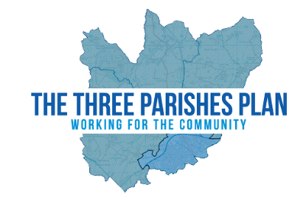
Your comments will be read carefully and taken into account when making any modifications to the Draft Plan.
Please note that by completing this response, you accept that Three Parishes Neighbourhood Plan can store the personal data you have provided in this form and use it in the preparation of the neighbourhood plan.

Policy Name | Page | Comment

