Community and Governance Committee Meeting | 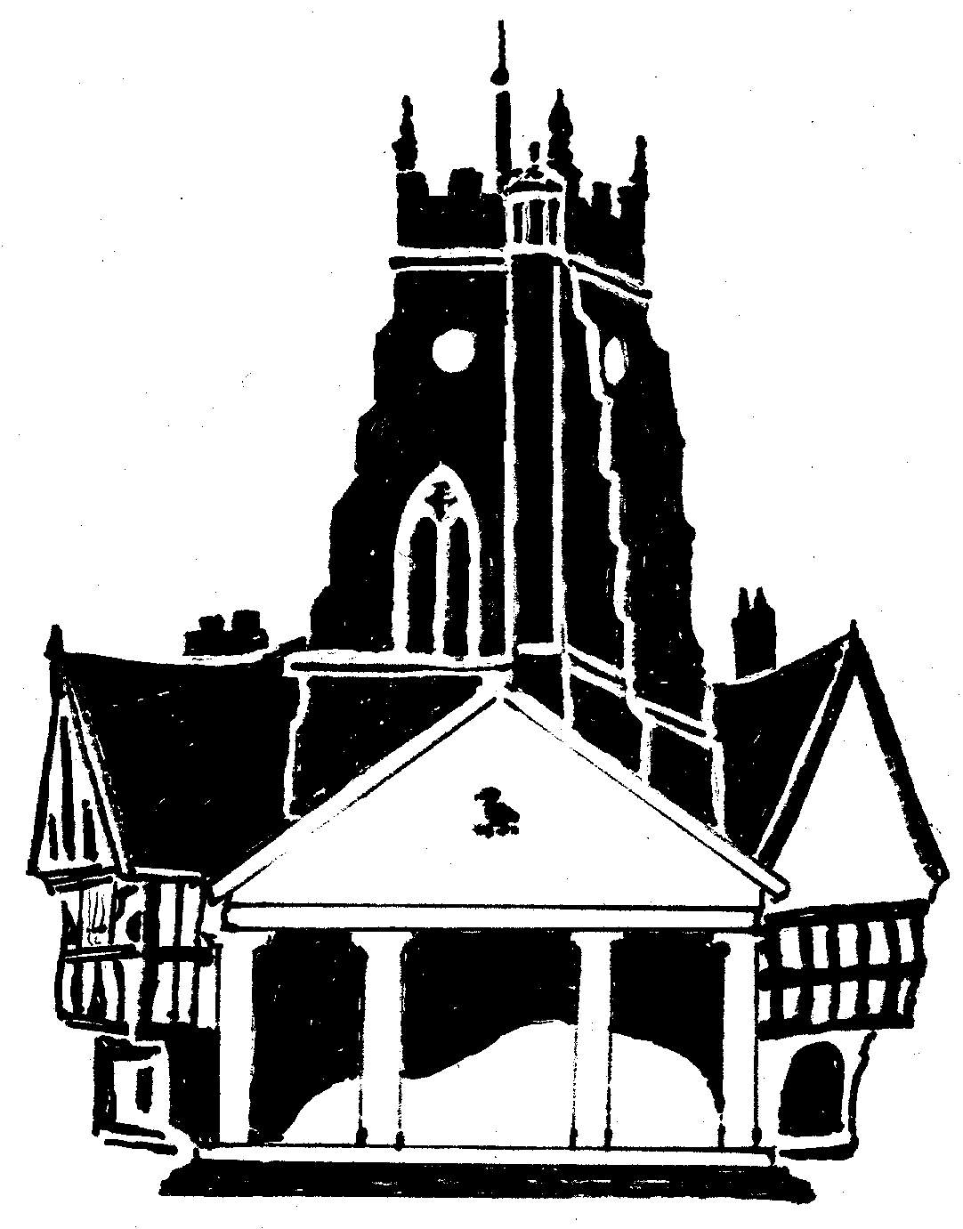  Market Drayton  Town Council
Agenda Item: 5.CG The Messenger

Date: 26th January 2023

Appendix : CG115

Market Drayton Messenger
Future Running Costs – Proposals From Market Drayton CIC
The team behind the ‘Drayton Messenger’ magazine met in early November to discuss costings and to make a roadmap to secure the future for the magazine. The magazine currently consists of 24 pages (12 of which are adverts, 12 of which are community news that’s printed with no charge) and is distributed to the whole of the TF9 area. The current and predicted figures based off estimates from NS Print are as follows:
Actual Actual Predicted
Oct-21 Oct-22 Mar-23
Regional distribution (12000 copies) by Royal Mail £1,434 £1,454 £1,500
Printing 12000 x 24 page magazine by NS Print £2,584 £3,290 £3,600

With this in mind we have proposed to increase the advertising by around 10% (give or take to make round numbers) however with 12 pages of advertising and based off current adverts this will still leave us with an annual shortfall of around £1000
We have 2 possible proposals to keep the same level of service the messenger currently has delivered to the whole of the TF9 area:
• Option 1: We request an additional £1000 per annum from Market Drayton Town Council to cover the shortfall
- Option 2: We write to the local parish councils and offer them space in the messenger for their own community news (we expect this to be 1x a4 side minimum and will increase the messenger to 28 pages which will be covered with the contributions from parishes if they feel this is a suitable advertising alternative)
We do have a 3rd option which would reduce some but not all costs and that’s to reduce the coverage down to just the area covered by Market Drayton Town Council but I don’t feel this will go down with advertisers as they are still paying the same amount for their advert which has less reach

Market Drayton Messenger
2023 Predicted Income/ Expenditure
(figures are based off previous income & estimates of work)

Income:
The current income for the Drayton Messenger magazine comes from 2 revenue streams, these are from Market Drayton Town Council Grants & Advertising Revenue.
Market Drayton Town Council Grants (annual) £7000
Predicted Advertising Revenue (annual) £11000
Total £18000

Expenditure:
The main costs associated with the production of the Drayton Messenger are the printing and distribution costs, there are also additional costs such as external writers, design & layout costs and admin costs.
Printing £11000
Distribution £5000
Design/ Layout £1500
External Writers £300
Admin £1500
Total £19300

Surplus/ Deficit
If we continue to print/ distribute the messenger in its current form, the magazine will run with a deficit of over £1000 annually. There for we have presented you with the proposals you have already seen.
Note: Advertising figure above is based on a 10% increase in advertising that has been agreed to be implemented from the next issue. All other figures are current.

