Community and Governance Committee Meeting | 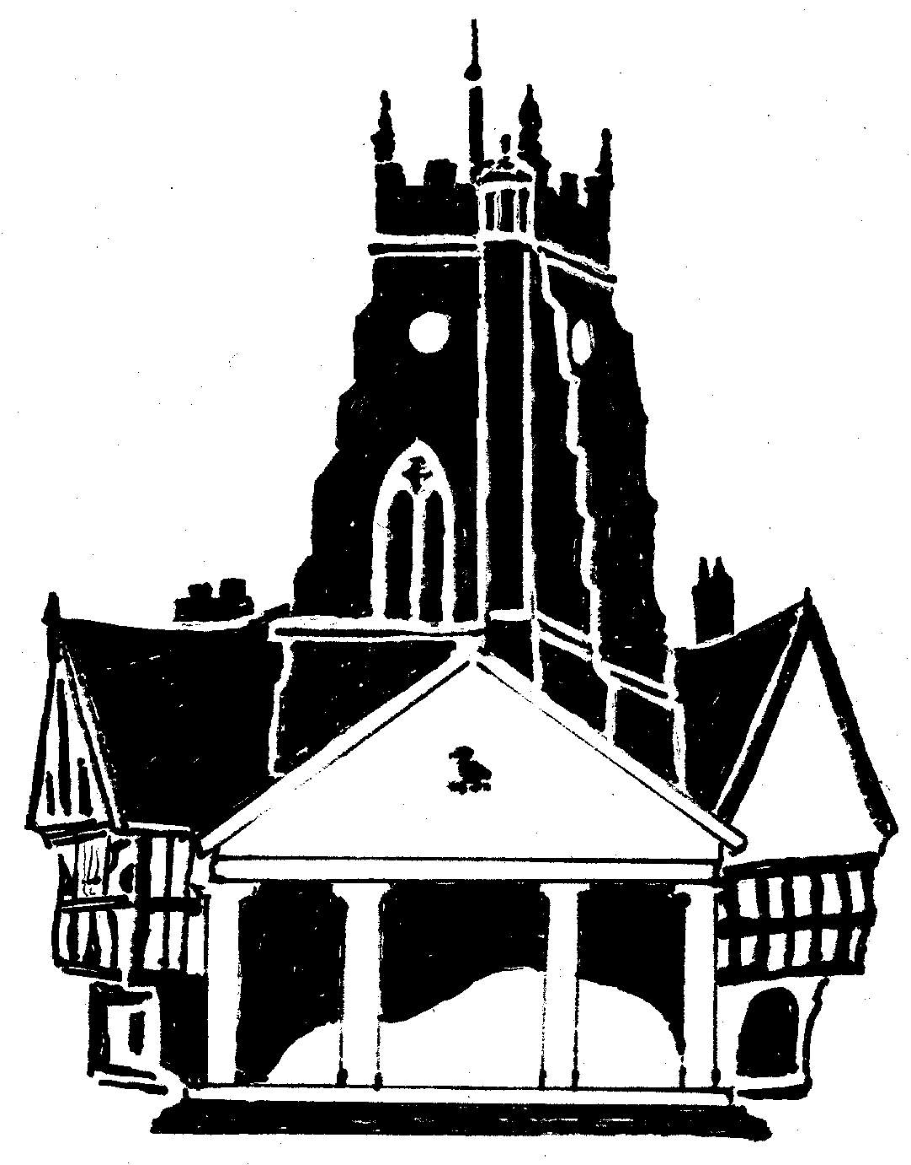  Market Drayton  Town Council
Agenda Item: 7.CG Building Condition Inspection

Date: 26th January 2023

Appendix : CG117

Background Information
It was resolved to carryout out a survey of the condition of town centre properties at the Community and Governance meeting on 27 February 2022. It was further resolved at the Community and Governance meeting held on 29th September 2022 to send letters to the owners/occupiers notifying of them of the condition survey and issues identified with the properties as part of the survey.
The building condition report was carried out on the 08/07/22 and 14/07/22 by Councillors Roberts, Manton and Chapman.
The inspection identified a total of 61 separate issues related to 47 individual properties, some properties obviously having more than 1 observation/issue. The issues were all logged on a spreadsheet.
Update
In November letters, along with pictures of the issues identified, were delivered to the properties requesting that the repairs be undertaken.
Responses were received from 7 owners/occupiers: some work was already being undertaken others have plans for the work to be undertaken.
A copy of the spreadsheet was forwarded to Shropshire Council. A response has been received stating that Officers can work with the Town Council to address issues where the condition of land or buildings adversely affects the amenity of an area and where a section 215 notice could be issued. (A section 215 notice requires the owners to deal with the poor state of a building).
Shropshire Council also suggested exploring the possibility of accessing the Shared Prosperity Fund. Shropshire Council has recently been granted £12.4 million, the three investment priorities within the funding parameters are communities and place, local businesses, and people and skills.
Next Steps
To formalise a working group for this project and elect members to the group.
To arrange a meeting with officers from Shropshire Council to discuss what actions can be taken regarding properties in the town and to discuss potential town centre regeneration projects that could be funded through the Shared Prosperity Fund.

