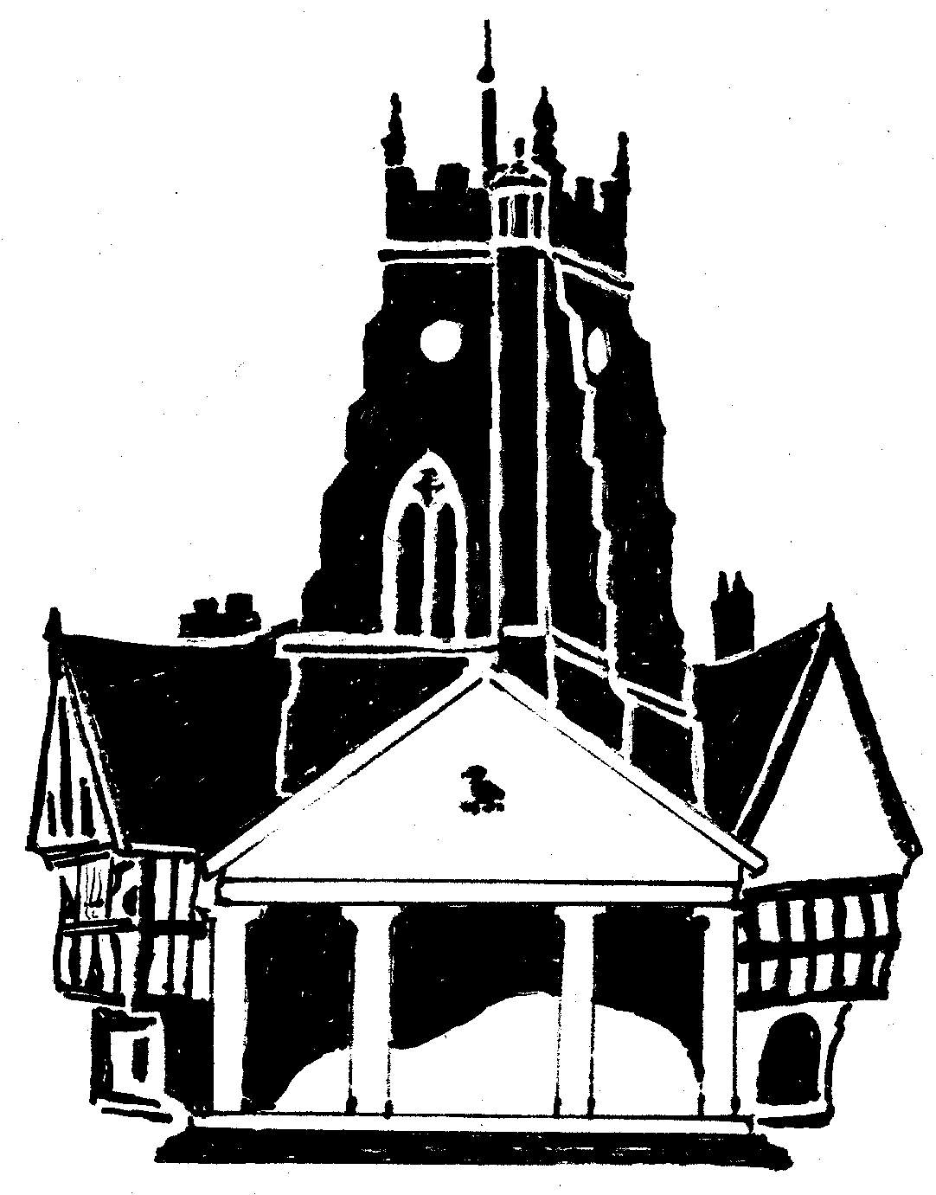
Market Drayton Town Council

CO-OPTION OF A COUNCILLOR FOR
THE NORTH WARD
MARKET DRAYTON TOWN COUNCIL

Market Drayton Town Council recently advertised a casual
vacancy for the statutory notice period, but no requests were
received for a by-election to be held.

Applications are now being sought from any suitably qualified
person who wishes to stand for co-option onto the Council.

Written applications should be made to the Clerk of the Council
by no later than Wednesday 21 June 2023 and these will be considered at
the Town/Parish Council Meeting to be held on Thursday 29 June 2023.

For an application pack, please contact:
Town Clerk
Market Drayton Town Council
18 Frogmore Road
Market Drayton
TF9 3AX
Tel: 01630 653364
Email: townclerk@marketdrayton.gov.uk

