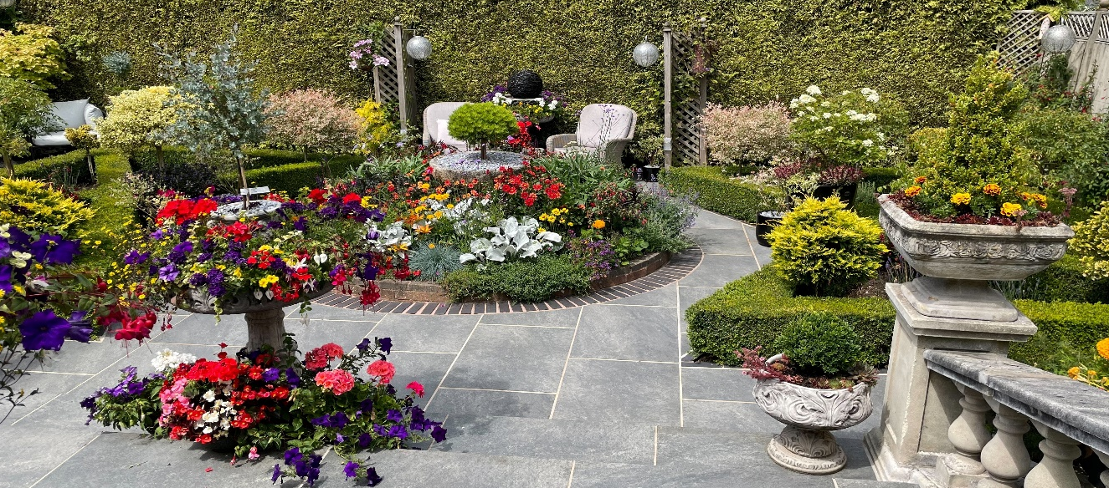
Market Drayton Town Council
In Bloom
Gardening Competition

In Bloom Application Form 2023
Residential Entries

[ ] Best Front Garden

[ ] Best Back Garden

[ ] Best Patio Display

[ ] Best Allotment/Vegetable Garden

[ ] Best Water Garden

[ ] Environmentally Friendly Garden

[ ] Best Group Dwelling

[ ] Best Hanging Basket/Planter/ Window Box

[ ] Best School Your details Name:
Address:

Telephone:
Please indicate which categories you wish to enter and complete the
details opposite. The winner of each category will receive a prize and a trophy to be held for one year, presented
at an awards ceremony in September.

Return this form to:

The Town Hall, 18 Frogmore Road, Market Drayton, TF9 3AX Telephone: 01630 653364 or
email: admin@marketdrayton.gov.uk Closing date for entries is Friday 14th July 2023

