Community and Governance Committee Meeting | 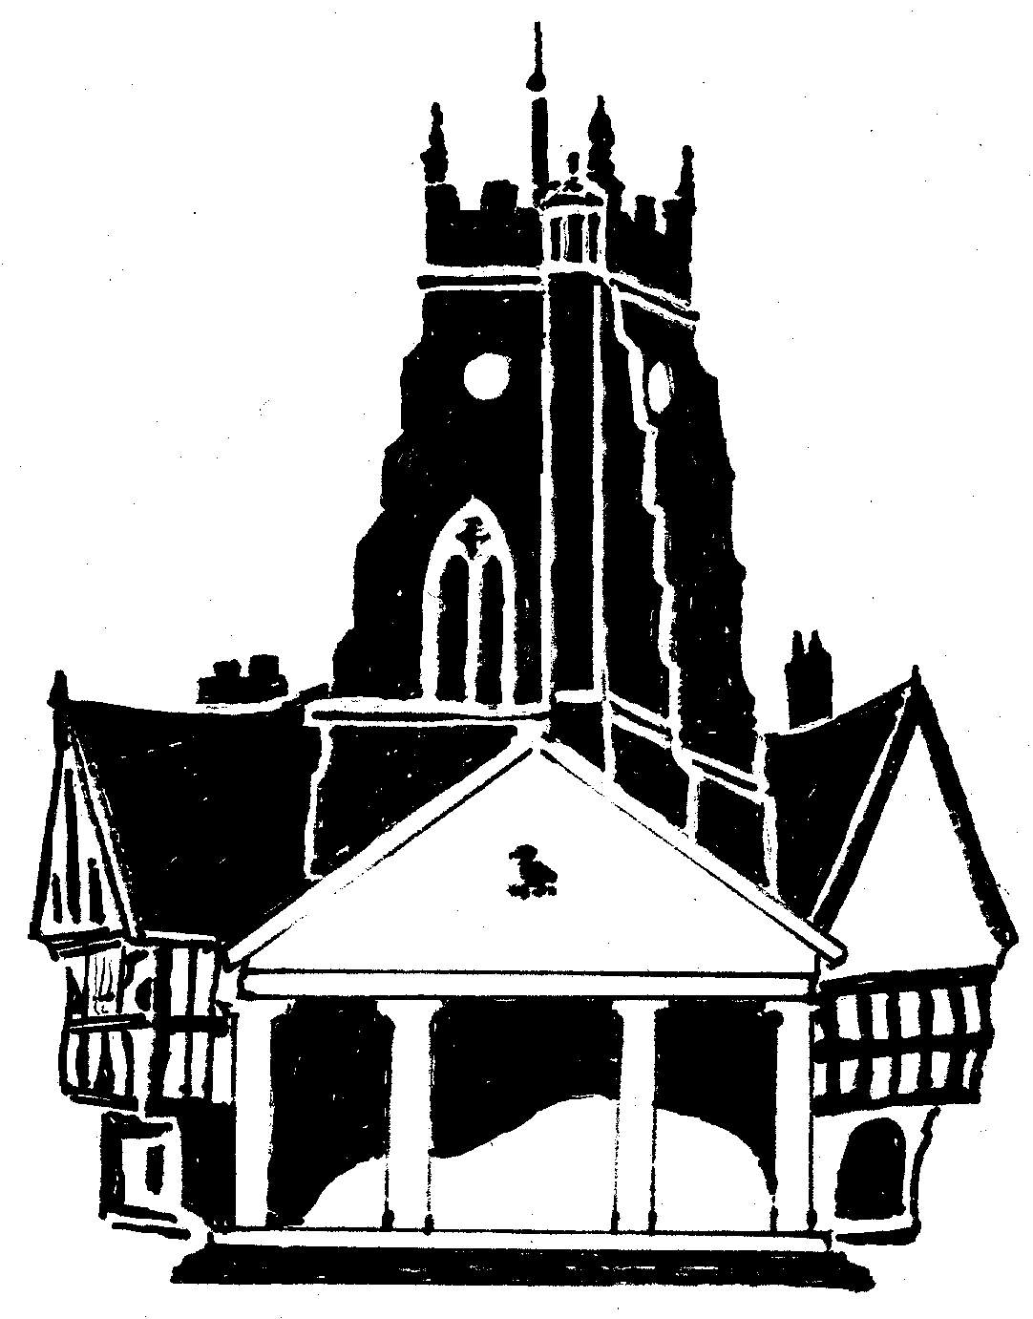  Market Drayton  Town Council
Agenda Item: 6.PL Appeal to the Secretary of State

Date: 27 July 2023

Appendix : PL45a

Planning Application Reference: 22/01176/FUL

Address: Former Phoenix Garage, Great Hales Street, Market Drayton, Shropshire.

Development: Redevelopment of site to provide a circa 60 Bed care home (use class C2) including access, parking and landscaping

Previous representations made by the Town Council:

Comment submitted date: Fri 29 Jul 2022

To object to this amended planning application due to:
- Loss of light/overshadowing
- Overlooking/loss of privacy
- Visual amenity
- Highway safety
- Erect on conservation area
- Layout and density
- Design, appearance, and materials

Comment submitted date: Fri 08 Apr 2022

To object to this planning application due to:
- Design and appearance - not in keeping with the surrounding conservation area
- Layout and density - overcrowding of the area
- Carparking - Insufficient carparking spaces
- Access - Lack of a turning space for emergency vehicle
- The application to be considered at Shropshire Council Planning Committee.

