Community and Governance Committee Meeting | 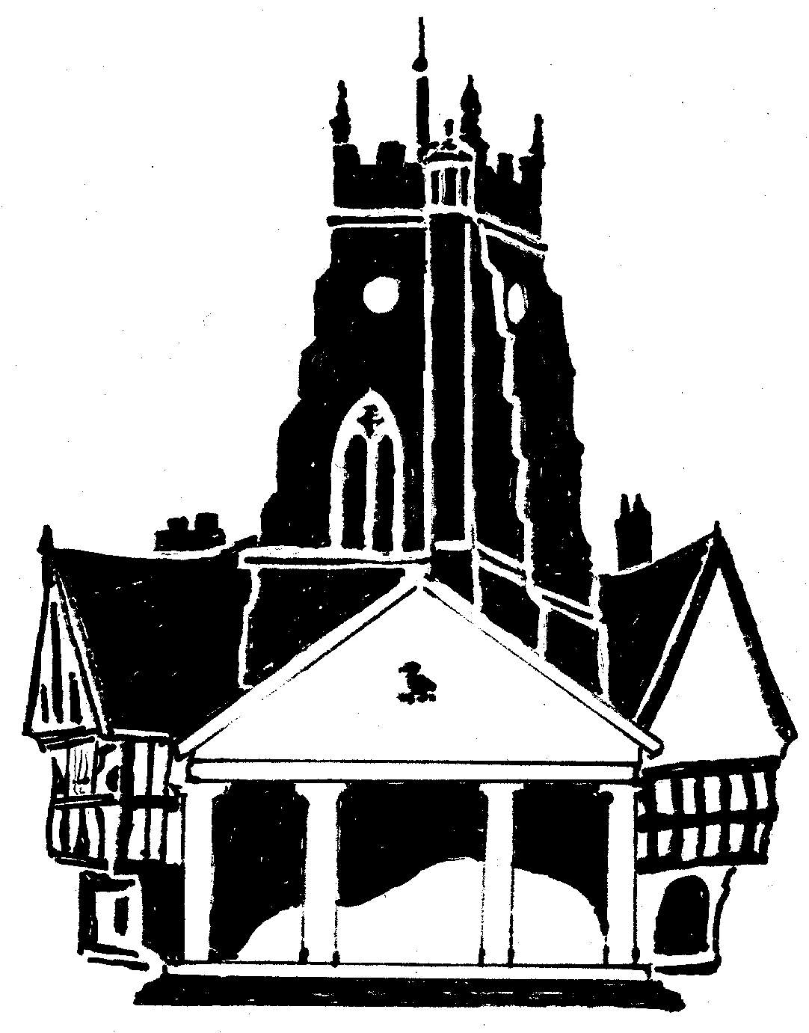  Market Drayton  Town Council
Agenda Item: 3.CG Saturday Bus Service (IN)

Date: 27 July 2023

Appendix : CG48

BACKGROUND
At the community and Governance meeting on the 29 June it was Resolved:
To obtain costings for the Town Council to subsidise the Saturday bus service to allow passengers to travel free.
AIM
Subsidising the town bus service would encourage residents to use local transport and reduce car travel into and around the town.
This would compliment the work currently being undertaken which is looking at the possibility of reconfiguring the existing provision to meet local need and demand and incorporate new housing developments.
COSTINGS
The following information has been obtained:
The average number of passengers using the service over 4 Saturdays is 50 paying @£1.20 and 85 concessions (passes).
Based on the average figures, this would equate to a subsidy of:
Per week = £60
6 months = £1,560
Annually = £3,120
Until the 31 March 2023 = £1,980 (starting mid August)
If successful and more residents use the free bus service, the above costs would increase.
There is currently £5,000 in the Community and Governance Budget.
FOR CONSIDERATION
To consider subsidising a trial initiative to provide free travel for passengers on the Saturday town bus service until the 31st March 2024.

