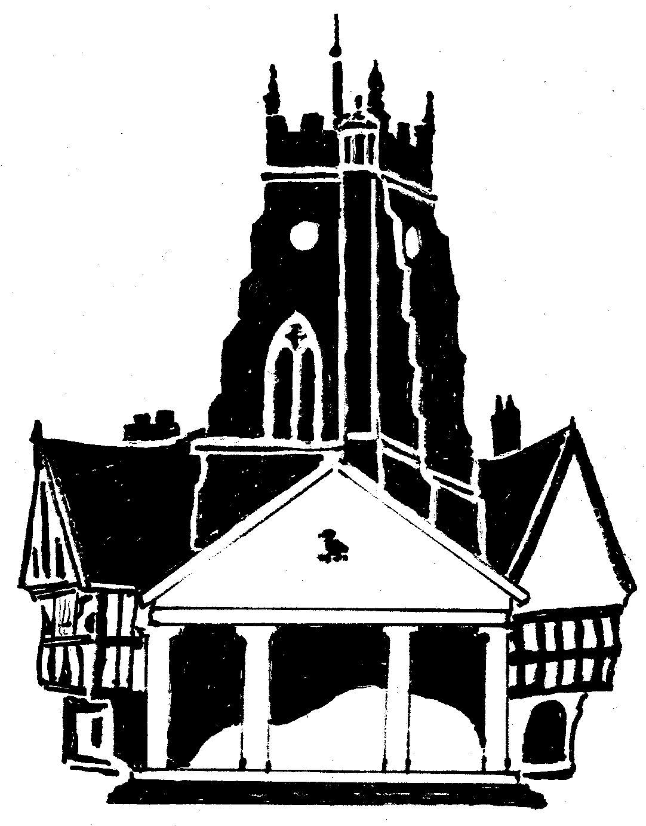
Market Drayton Town Council

CO-OPTION OF A COUNCILLOR FOR
THE NORTH WARD
MARKET DRAYTON TOWN COUNCIL

Market Drayton Town Council recently advertised a casual
vacancy for the statutory notice period, but no requests were
received for a by-election to be held.

Applications are now being sought from any suitably qualified
person who wishes to stand for co-option onto the Council.

Written applications should be made to the Clerk of the Council
by no later than Thursday 9 November 2023 and these will be considered at the next appropriate Council meeting.

For an application pack, please contact:
Town Clerk
Market Drayton Town Council
18 Frogmore Road
Market Drayton
TF9 3AX
Tel: 01630 653364
Email: townclerk@marketdrayton.gov.uk

