Community and Governance Committee Meeting | 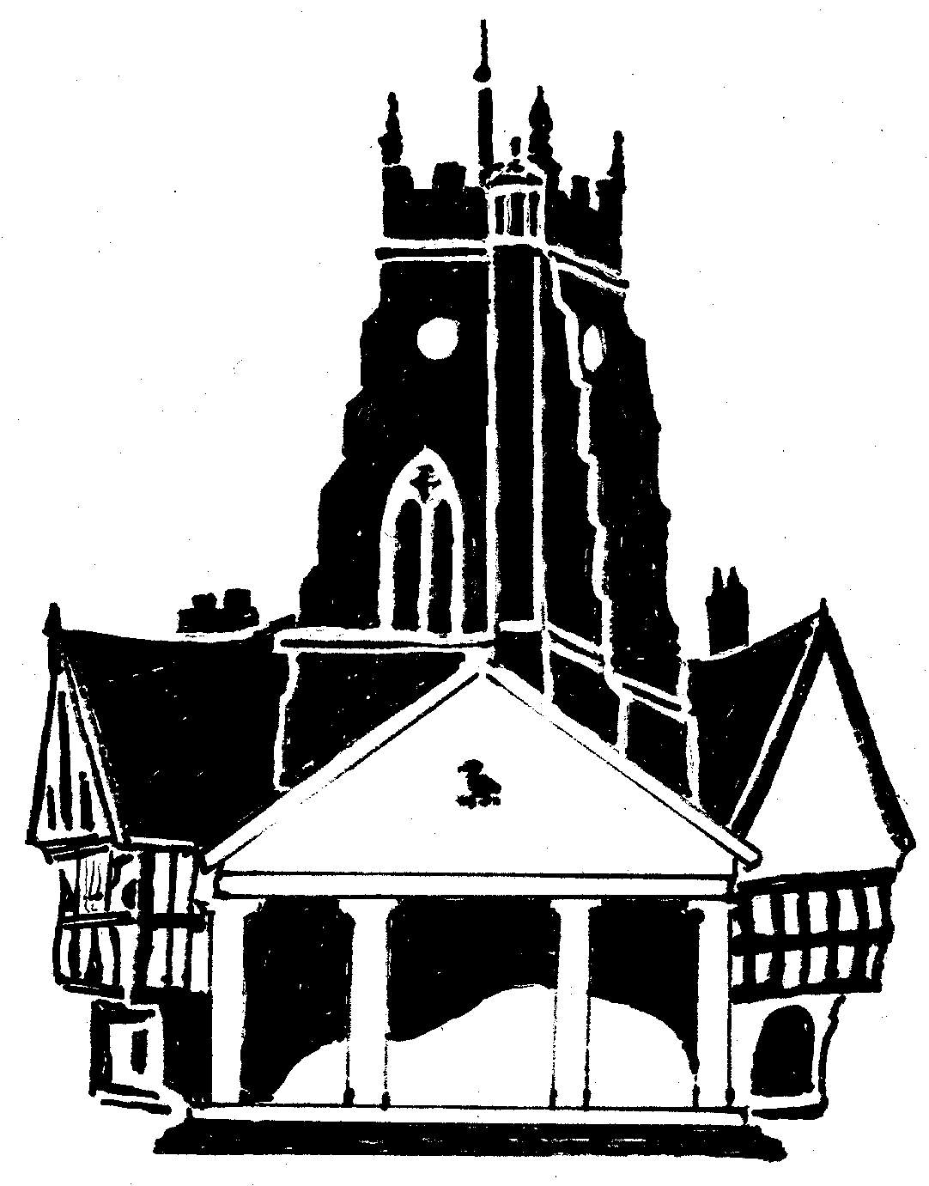  Market Drayton  Town Council
Agenda Item: 4.CG Three Parishes Neighbourhood Plan - Statutory (reg 16) Consultation

Date: 27 July 2023

Appendix : CG49

BACKGROUND
Adderley, Moreton in Say and Norton Hales Parish Councils have prepared a Neighbourhood Plan in accordance with Regulation 15 of the Neighbourhood Planning (General) (Amendment) Regulations 2015.

Adderley, Moreton in Say and Norton Hales Parish Councils have submitted their Neighbourhood Plan to Shropshire Council. The submission is accompanied by a Summary Document, the Basic Conditions Statement, Consultation Statement, Strategic Environmental Assessment (SEA) Screening Assessment and the Habitats Regulations Assessment (HRA) Screening Assessment.

PUBLICATION AND CONSULTATION OF THE NEIGHBOURHOOD PLAN

As required by Regulation 16 of the Neighbourhood Planning Regulations, Shropshire Council is inviting representations during a public consultation on the submission version of the Three Parishes Neighbourhood Plan.

Representations are now invited on the submitted version of the neighbourhood plan. The consultation documents can be downloaded and viewed on this page: https://www.shropshire.gov.uk/planning-policy/neighbourhood-and-community-led-plans/emerging-neighbourhood-plans/three-parishes-neighbourhood-plan/.

FOR CONSIDERATION
To consider and respond to the Three Parishes Neighbourhood Plan – Statutory (Reg 16) Consultation

