Community and Governance Committee Meeting | 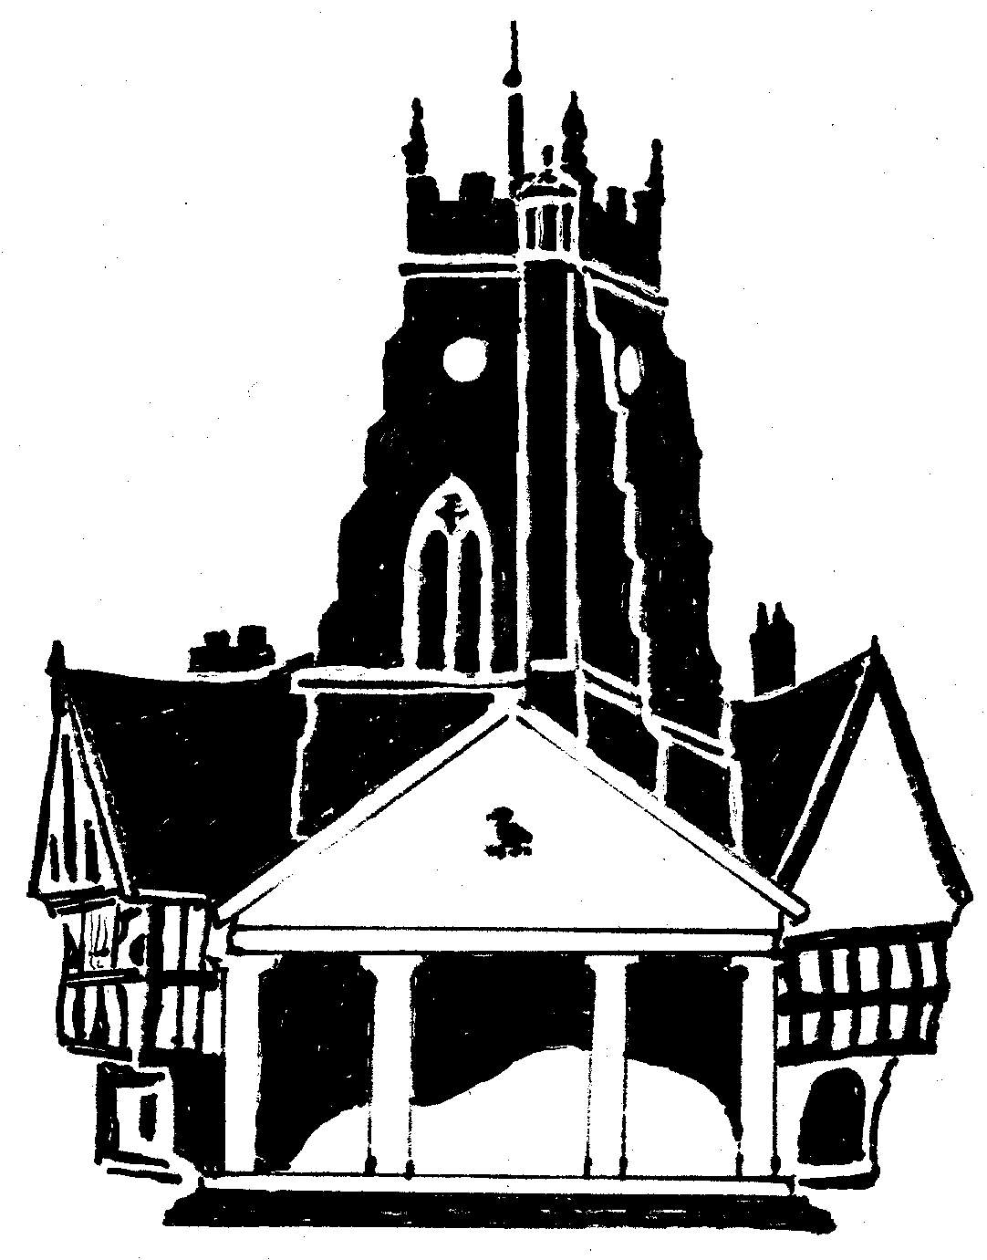  Market Drayton  Town Council
Agenda Item: 7.CG Town Map/Guide

Date: 21 September 2023

Appendix : CG67

A number of Market Drayton Town Maps are currently in existence, most of which are out of date, unsuitable or don’t portray Market Drayton in the light we would wish it to be portrayed.
A Town Map/guide is an important document for potential visitors to our Town, a document that quickly and easily identifies places of interest, walks, shops, pubs, open spaces, canal towpaths etc etc….
A Town Map/guide that is up-to-date, professionally prepared, appealing and full of valuable information can be a fantastic tool to make a visitors time in Market Drayton one which lives long in the memory and promotes future visitors to our Town.
A Town Map/guide that includes advert space for our local groups and trading entities may potentially have wonderful benefits to our local economy.
A Town Map/guide is a potential tool to spread far and wide, an example of this being the Town Councils membership of Visit Shropshire who attend a number of tourism events and are happy to distribute information on Shropshire Towns under their membership.
Market Drayton has a fantastic opportunity in producing a good Town Map/guide having the potential to promote great tourism to our Town showcasing the most wonderful aspects we have to offer.
To be considered
To consider producing an updated town map/guide.

