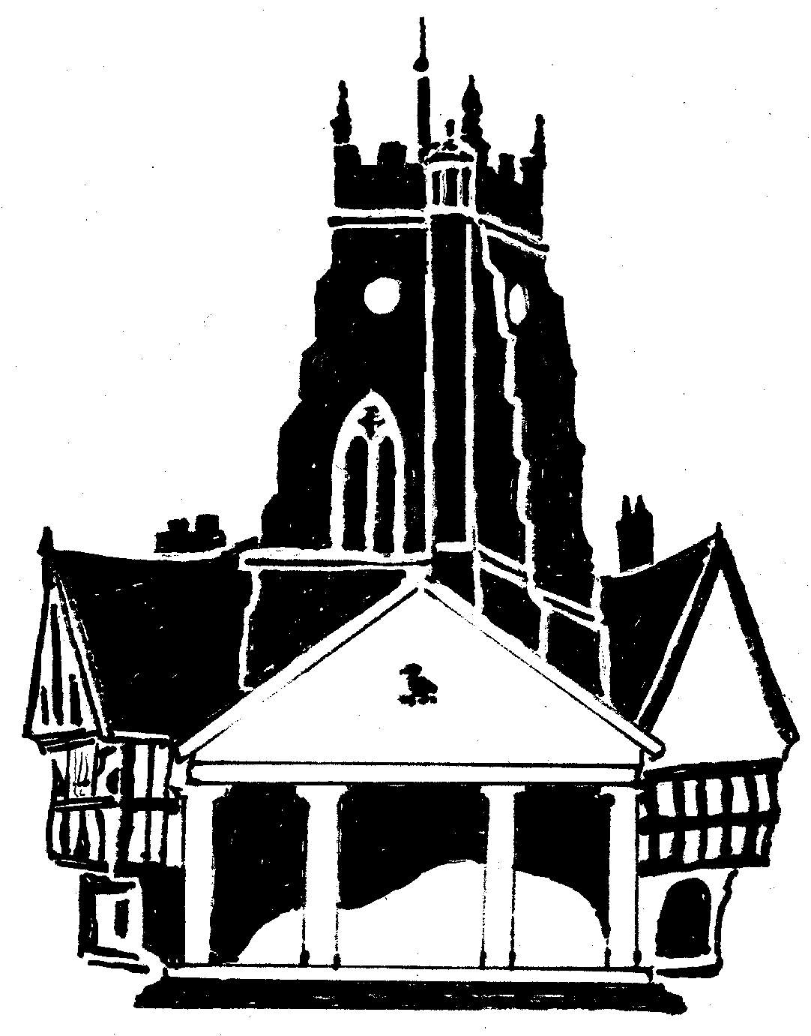
MARKET DRAYTON TOWN COUNCIL
PRIVACY POLICY

This policy had been created in order to comply with the new General Data Protection Regulations (GDPR) which come into force on 25th May 2018 and supersedes the existing Data Protection Act 1998.
Your personal data – what is it?
“Personal data” is any information about a living individual, which allows them to be identified from that data (for example a name, photographs, videos, email address, or address). Identification can be by the personal data alone or in conjunction with any other personal data. The processing of personal data is governed by legislation relating to personal data, which applies in the United Kingdom including the General Data Protection Regulation (the “GDPR) and other local legislation relating to personal data and rights such as the Human Rights Act.
Council information
This Privacy Policy is provided to you by Market Drayton Town Council, which is the data controller for your data.
The Council’s address is: Market Drayton Town Council, The Town Hall, 18 Frogmore Road, Market Drayton, Shropshire,TF9 3AX.
Definitions of GDPR roles
Data Controller – Market Drayton Town Council, will ensure that the GDPR principles are followed in the management of personal data.
Data Protection Officer – should assist the Controller or the processor to monitor internal compliance with the Regulations.
Data Processor – is the person that processes the data on behalf of the controller adhering to the GDPR principles.

Other data controllers
• Local Authorities/Parish Councils
• Community Groups
• Charities
• Other not for profit entities
• Contractors
• Credit reference agencies
The Council will process some or all of the following personal data where necessary to perform its tasks.
• Names, titles, and aliases, photographs;
• Contact details such as telephone numbers, addresses, and email addresses;
• Where they are relevant to the services provided by a council, or where you provide them to us, we may process demographic information such as gender, age, , marital status, nationality, education/work histories, academic/professional qualifications, hobbies, family composition, and dependants;
• Where you pay for activities such as use of a council hall, financial identifiers such as bank account numbers, payment card numbers, payment/transaction identifiers, policy numbers, and claim numbers;
• The data we process may include sensitive personal data or other special categories of data such as racial or ethnic origin, mental and physical health, details of injuries, medication/treatment received, political beliefs, trade union affiliation, genetic data, biometric data, data concerning and sex life or sexual orientation.
The council will comply with Data Protection Law. This says that the personal data we hold about you must be:
• Used lawfully, fairly and in a transparent way.
• Collected only for valid purposes that we have clearly explained to you and not used in any way that is incompatible with those purposes.
• Relevant to the purposes we have told you about and limited only to those purposes.
• Accurate and kept up to date.
• Kept only as long as necessary for the purposes we have told you about.
• Kept and destroyed securely including ensuring that appropriate technical and security measures are in place to protect your personal data to protect personal data from loss, misuse, unauthorised access and disclosure.

We use your personal data for some or all of the following purposes:
• To deliver public services including to understand your needs to provide the services that you request and to understand what we can do for you and inform you of other relevant services;
• To confirm your identity to provide some services;
• To contact you by post, email, telephone or using social media (e.g., Facebook, Twitter, WhatsApp);
• To help us to build up a picture of how we are performing;
• To prevent and detect fraud and corruption in the use of public funds and where necessary for the law enforcement functions;
• To enable us to meet all legal and statutory obligations and powers including any delegated functions;
• To carry out comprehensive safeguarding procedures (including due diligence and complaints handling) in accordance with best safeguarding practice from time to time with the aim of ensuring that all children and adults-at-risk are provided with safe environments and generally as necessary to protect individuals from harm or injury;
• To promote the interests of the council;
• To maintain our own accounts and records;
• To seek your views, opinions or comments;
• To notify you of changes to our facilities, services, events and staff, councillors and role holders;
• To send you communications which you have requested and that may be of interest to you. These may include information about campaigns, appeals, other new projects or initiatives;
• To process relevant financial transactions including grants and payments for goods and services supplied to the council
• To allow the statistical analysis of data so we can plan the provision of services.
Our processing may also include the use of CCTV systems for the prevention and prosecution of crime.
What is the legal basis for processing your personal data?
The council is a public authority and has certain powers and duties. Most of your personal data is processed for compliance with a legal obligation which includes the discharge of the council’s statutory functions and powers. Sometime when exercising these powers or duties it is necessary to process personal data of residents or people using the council’s services. We will always take into account your interests and rights. This Privacy Policy sets out your rights and the council’s obligations to you in detail.
We may also process personal data if it is necessary for the performance of a contract with you, or to take steps to enter into a contract. An example of this would be processing your data in connection with the use of sports facilities, or the acceptance of an allotment garden tenancy.
Sometimes the use of your personal data requires your consent. We will first obtain your consent to that use.
Sharing your personal data
The council will implement appropriate security measures to protect your personal data. This section of the Privacy Policy provides information about the third parties with whom the council will share your personal data. These third parties also have an obligation to put in place appropriate security measures and will be responsible to you directly for the manner in which they process and protect your personal data. It is likely that we will need to share your data with some or all of the following (but only where necessary):
Our agents, suppliers and contractors. For example, we may ask a commercial provider to publish or distribute newsletters on our behalf, or to maintain our database software;
On occasion, other local authorities or not for profit bodies with which we are carrying out joint ventures e.g. in relation to facilities or events for the community.
How long do we keep your personal data?
We will keep some records permanently if we are legally required to do so. We may keep some other records for an extended period of time. For example, it is current best practice to keep financial records for a minimum period of 8 years to support HMRC audits or provide tax information. We may have legal obligations to retain some data in connection with our statutory obligations as a public authority. The council is permitted to retain data in order to defend or pursue claims. In some cases the law imposes a time limit for such claims (for example 3 years for personal injury claims or 6 years for contract claims). We will retain some personal data for this purpose as long as we believe it is necessary to be able to defend or pursue a claim. In general, we will endeavour to keep data only for as long as we need it. This means that we will delete it when it is no longer needed.
Your rights and your personal data
You have the following rights with respect to your personal data:
When exercising any of the rights listed below, in order to process your request, we may need to verify your identity for your security. In such cases we will need you to respond with proof of your identity before you can exercise these rights.
• The right to access personal data we hold on you
• The right to correct and update the personal data we hold on you
• The right to have your personal data erased
• The right to object to processing of your personal data or to restrict it to certain purposes only
• The right to data portability
• The right to withdraw your consent to the processing at any time for any processing of data to which consent was obtained
• The right to lodge a complaint with the Information Commissioner’s Office. You can contact the Information Commissioners Office on 0303 123 1113 or via email https://ico.org.uk/global/contact-us/email/ or at the Information Commissioner's Office, Wycliffe House, Water Lane, Wilmslow, Cheshire SK9 5AF.
Transfer of Data Abroad
Any personal data transferred to countries or territories outside the European Economic Area (“EEA”) will only be placed on systems complying with measures giving equivalent protection of personal rights either through international agreements or contracts approved by the European Union. [Our website is also accessible from overseas so on occasion some personal data (for example in a newsletter) may be accessed from overseas].
Further processing
If we wish to use your personal data for a new purpose, not covered by this Privacy Policy, then we will provide you with a Privacy Notice explaining this new use prior to commencing the processing and setting out the relevant purposes and processing conditions. Where and whenever necessary, we will seek your prior consent to the new processing.
Changes to this policy
We keep this Privacy Policy under regular review and we will place any updates on Market Drayton Town Council website. This Policy was last updated in June 2018.
Contact Details
Please contact us if you have any questions about this Privacy Policy or the personal data we hold about you or to exercise all relevant rights, queries or complaints at: Market Drayton Town Council, The Town Hall, 18 Frogmore Road, Market Drayton, Shropshire, TF9 3AX

Adopted by the Council’s Finance and General Purposes Committee: 21 June 2018
Reviewed with no updates at a Finance and General Purpose Committee: 7 September 2023

