Services and Facilities Committee Meeting | 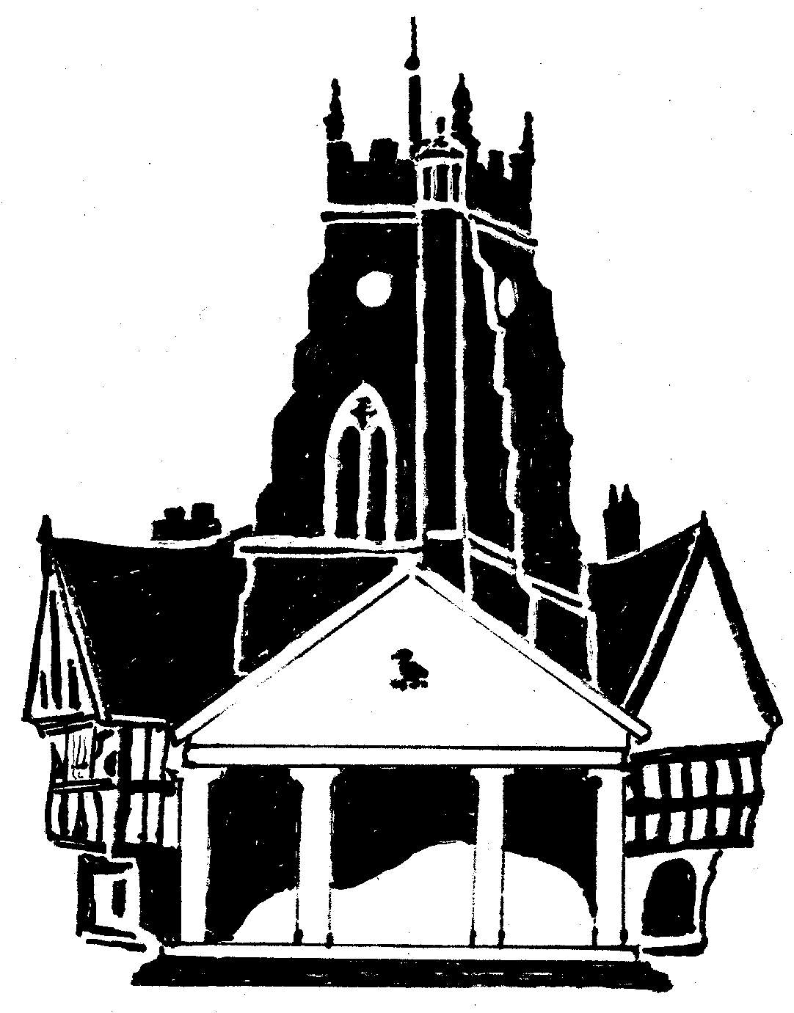  Market Drayton  Town Council
Agenda Item: 6.SF CCTV – ii. Receiver

Date: 5 October 2023

Appendix : SF75

The Wi-fi link is being disrupted by the trees on Cheshire Street, outside the library. A request for the trees to be crowned has been submitted to Shropshire Council. The following response has been received ‘Unfortunately, we are receiving a high number of enquiries at this time and there may be a delay before anyone can get out’.

As no time frame has been provided for the trees to be crowned an alternative is to have the wi-fi signal receiver moved along the building to provide a better line of site. The quotes below have been received.

 | To move the wi-fi signal receiver on Cheshire Street.
Quote A | £350.00
Quote B | £630.00

