Services and Facilities Committee Meeting | 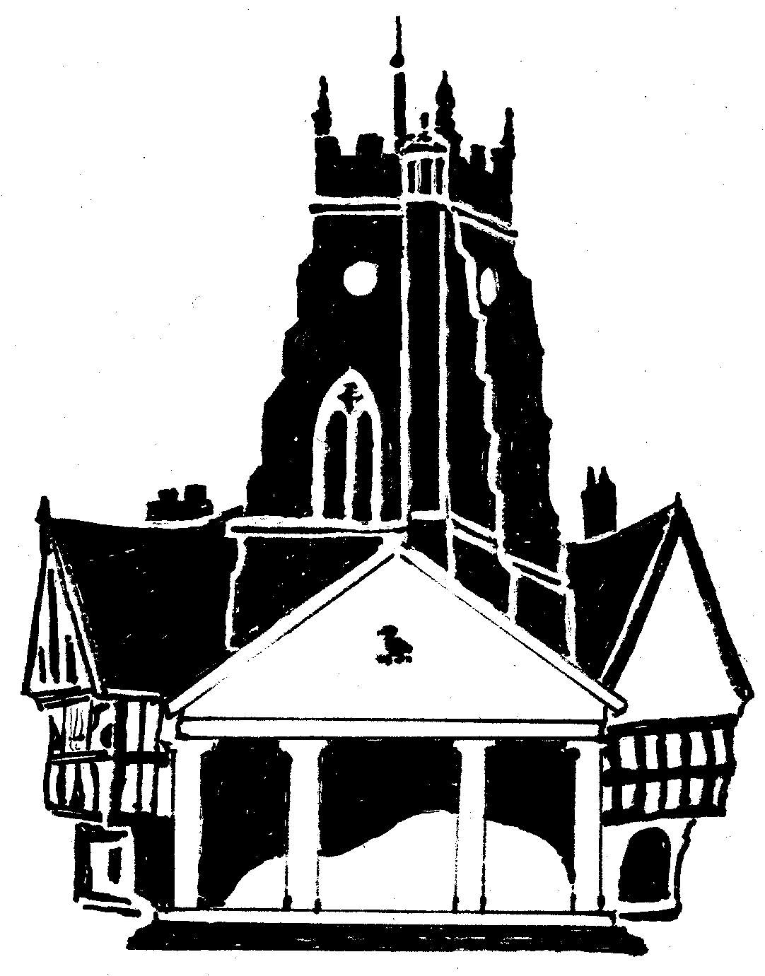  Market Drayton  Town Council
Date: 5 September 2023

Agenda Item: 8.SF Recreation Grounds – ii. Skate Park

Appendix : SF78

CIL Neighbourhood Fund - £104,720

Skate Park | Funding Source | To consider:
To install a youth shelter | Neighbourhood Fund | Consulting with young people about the installation of a youth shelter by the skatepark.  To obtain permission from Shropshire Council for a youth shelter to be installed.  To obtain quotes for the installation of a youth shelter to be presented by the committee.
To install solar panel lights | Neighbourhood Fund | Obtaining quotes for the installation of a solar light by the skatepark.  Obtaining permission from Shropshire Council for a solar light to be installed.

Youth Shelter Examples
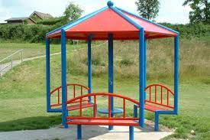 | 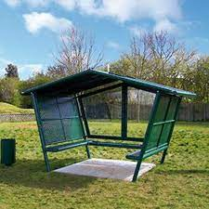
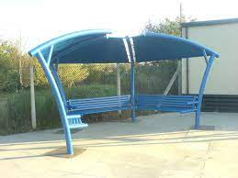 | 