Services and Facilities Meeting

5 October 2023

Appendix SF79

TERMLY MONITORING AND EVALUATION SCHEDULE

The purpose of termly monitoring reports is to:
- Demonstrate how the club is meeting the aims and outcomes contained within the agreement and the statutory requirements;
- Gather service user feedback,
- Demonstrate that your services are listening and responding to service user feedback (children and where appropriate parents / carers).

The termly monitoring reports shall include:

Club/project name: | Market Drayton Junior youth club
Term: | Summer
Date: | July 2023

What we have done to increase/ improve physical health | This term young people have engaged in lots of sports due to the nature of the group who are very sporty and active. As we have had the summer months, we have had the big volleyball net out so they have enjoyed big team games of volleyball, tennis and badminton. Lee came over one evening and ran tag archery with the group, many of which had never played this sport before, but they really enjoyed it. Opportunity to learn a new sport which they always enjoy.  As always, they’ve taken part in table tennis, table football and pool competitions which are available to do each week.  James has bought over virtual reality headset a few times and they’ve also really enjoyed playing Just Dance and sport games on the Nintendo switch, which is good exercise in a fun way.  We have been to the local park for a few sessions so it gave us lots more space to play games such as cricket, rounders, football and races. They’ve also enjoyed playing on the gym equipment in the park.  We had a visit of two guys from UK Youth one evening so the group made them feel welcome and they enjoyed some swing ball, cricket and rounders with them.  They enjoyed singing and dancing to the silent disco and engaged in lots of archery both indoors and outdoors. Competing against each other to see who could get the highest score.  Skipping has also being popular this term enjoying the outdoor space and curling which has been popular. This gets competitive but is also quite a rare sport which they don’t learn at school.  Young people had the opportunity to go on a trip to Telford Inflatanation for our end of term trip. This was great fun and the group burnt off lots of energy. They represented the club well with their manners and brilliant behavior. Giving many the opportunity to go to somewhere they don’t get to go due to their parents not being able to drive or for financial reasons.  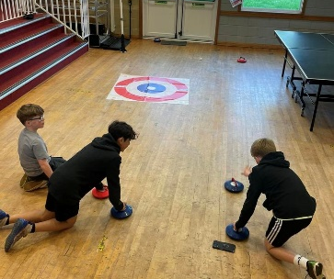
What we have done to increase/  improve Emotional health | Young people have spent lots of time in the kitchen this term. Lots of YP wanting to cook and bake so we have took advantage of the brilliant kitchen we have at the Centre and got cooking. They’ve made pizza’s, toasted sandwiches, beans on toast, cheese on toast, baked muffins, cupcakes, fruit waffles, doughnut decorating, fruit kebabs which is always a favorite although fruit is available as a snack each week, biscuit decorating,  One evening two girls decided they wanted a “bake off” so they both made separate cake mix’s and made and decorated their own cupcakes. They were then judged by other members testing to see which tasted the best and which looked the best. This kept them entertained and really enjoyed it.  For the last week of term YP enjoyed glitter tattoo’s and the etch sketch. Lots of Uno marathons have also being enjoyed along with making models with clay.  They have enjoyed a variety of art and craft activities such as rock painting, designing their own tiles, hama beading which again is always popular whilst chilling round the table chatting to eachother, designing their own canvases and liter wooden plaques which they took home to decorate their bedroom.  Another game which got lots of them engaged was pie face, messy but fun and got so many involved as a group.  We have had lots of chats about vaping with this been a big issue with young people now, especially in schools. We did this in a more fun way by doing a quiz and discussed the answers as a group afterwards. Lots of them learnt lots of facts around the health impacts and completed a wordsearch which again, created lots of discussions.  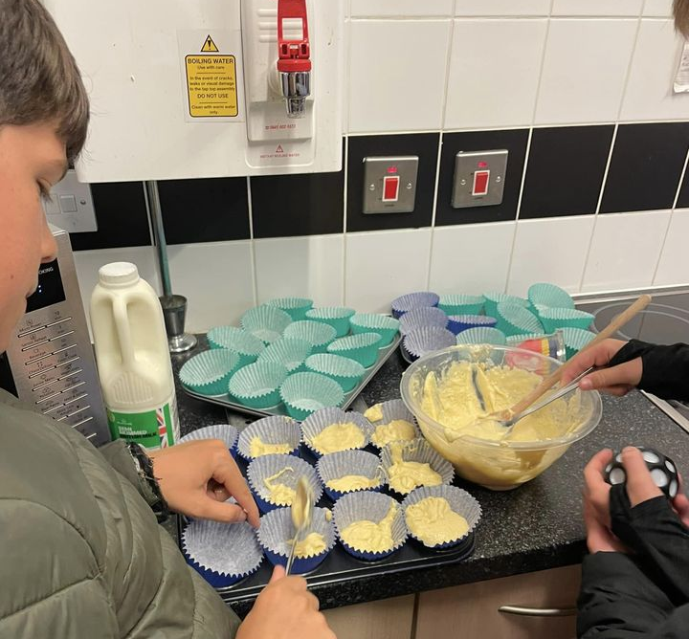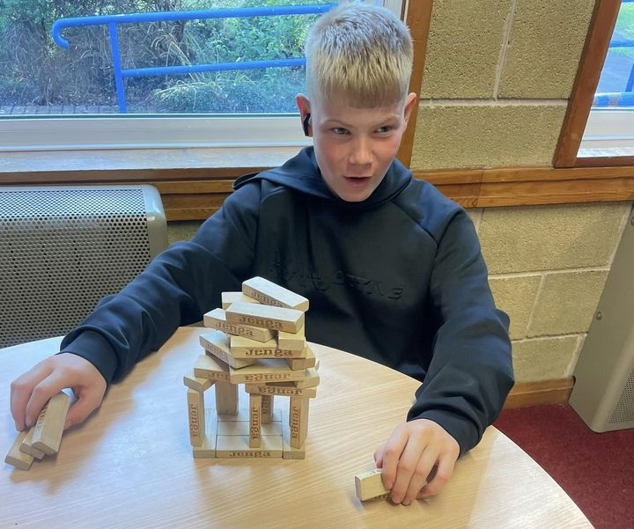

- Outputs Reporting

Total number of different individuals who have benefited from the activities since contract start | 88
Average attendance per session | 25

Number of individuals x frequency | Subject | Notes
1 | Bereavement | One YP lost a family member.
10 | Bullying | Issue in school.
20 | Confidence | Members engaging in activities they wouldn’t usually enjoy.
20 | Diet | Promoting a healthy balanced diet. Always fruit is available to snack on. Healthy food.
50 | Exercise | Keeping active. Taking part in PE at school. Outdoor games at club.
12 | Family | Relationships with parents.
40 | Getting active | Engaging in sports at club.
10 | Healthy eating | Promoted at club. Picking healthy snacks rather than unhealthy choices.
40 | Personal hygiene | Washing hands before preparing food.
14 | Public speaking | End of term school plays. Getting up on stage and facing thei fears.
14 | Relationships | Relationships and friendship breakdown. Difference of opinions. Some YP no longer come to club as new friends.
38 | School | End of term. Trips. Residentials – nervous/ excited about been away from home and family. Plays. Mixed emotions and leaving primary school and starting secondary school. Lots of exam stress – SATS. Pressure.
10 | Self esteem | Performing on stage.
22 | Smoking | Quiz. Word search. Discussions.
24 | Anxiety. | Mental health struggles. Not to be embarrassed to ask for help and support.

- Case study

Give an example where an intervention or series of interventions has contributed towards a young person/people’s behaviour, physical or emotional health or behaviour change.

K having lots of issues with friendship groups at the start of term.
Mum rang me concerned that she didn’t want to come out the house due to being frightened of being “beat up”. Came to club on a few occasions as it’s the only place she enjoys coming to and with not attending school somewhere to go where she’s safe out of the house. K hasn’t been for some weeks now as she’s lost her confidence to leave the house and return, but I have been in contact with her to check she’s ok and so she knows she is always welcome to come to club where she will be kept safe should she decide to return.
Lots of family issues, relationships issues in the past. Social services being involved.
We took K home one evening when mum asked us to do this but made her aware this could not be something we can do every week.

- Variation to service

Has there been any significant variation to the service that you were commissioned to provide in this quarter and what actions are you planning in response?

One session was cancelled due to staff sickness.

