Services and Facilities Meeting

5 October 2023

Appendix SF79

TERMLY MONITORING AND EVALUATION SCHEDULE

The purpose of termly monitoring reports is to:
- Demonstrate how the club is meeting the aims and outcomes contained within the agreement and the statutory requirements;
- Gather service user feedback,
- Demonstrate that your services are listening and responding to service user feedback (children and where appropriate parents / carers).

The termly monitoring reports shall include:

Club/project name: | Market Drayton Senior youth club
Term: | Summer
Date: | July 2023

What we have done to increase/ improve physical health | This term the seniors have taken part in a range of sport activities. More so than normal due to the lighter, warmer nights. They have enjoyed archery, volleyball, football, swing ball, rounders and cricket. Lots of team games and building relationships with the younger members of the group.  We went to the town park for one session to enjoy the gym equipment and a walk round the park.  Lee came over and ran tag archery one evening which they thoroughly enjoyed although they did get lots of targets stuck in the tree, but that was all part of the fun.  Two guys from UK Youth came over one evening and two lads engaged in lots of conversations with them, and they enjoyed a game of cricket and rounders with them.  Lots of table tennis, table football and pool as this is what the seniors like to do. They tend to like a more chilled session rather than it being too full on due to the older age range.  James got them to participate in Just Dance on the switch, so the girls and boys had a laugh doing this which got extremely competitive, but again they had a good laugh.  For the end of term, we had an egg and spoon race and some running races as a little sports evening along with some food.  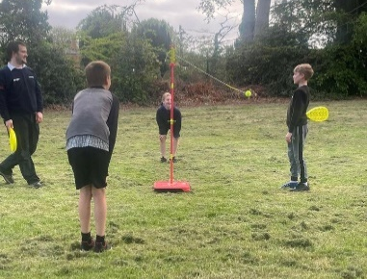
What we have done to increase/  improve Emotional health | Members have enjoyed lots of uno marathons and Hama beading whilst enjoyed a hot chocolate on many evenings this term.  They have also been very active in the kitchen, especially with baking. We got some of the seniors to make cupcakes independently and they saw the entire process through (seniors get easily distracted so this was a bonus).  The lads were very focused on getting involved in making the food for the session. They prepared fruit for the fruit kababs along with trying new fruits, making fruit waffles, cheesy beans on toast and sausage sandwiches, pizzas and biscuit decorating. This is what they chose.  Some of the younger members enjoyed the clay, playing pie face, designing their own mugs and tiles and little plaque keepsakes.  We have had lots of discussions around vaping where they completed a quiz and learnt about the dangers of this. They stated how easily accessible these are to get hold of. We discussed how to drink sensibly when out at friends' houses and going to parties at the weekends, to watch their drinks and not leave them unattended so nobody can put anything in them. They stated how they are often together and all friends, but this still doesn’t mean it won’t happen. They understood the dangers around this.  They enjoyed a music quiz where they shouted out the names of the songs. We also had a board game night playing connect 4, twister and guess who. This was nice and chilled, and the group really enjoyed it.  We also had a silent disco, so we had a sing along to the songs whilst having a little dance. Discussing the eras of songs and who the artist was.  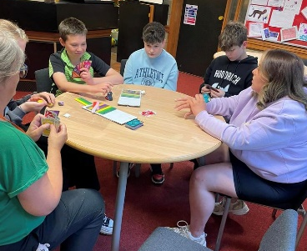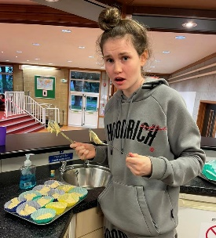

- Outputs Reporting

Total number of different individuals who have benefited from the activities since contract start | 92
Average attendance per session | 16

Number of individuals x frequency | Subject | Notes
22 | Alcohol | Dangers. Discussions around drinking sensibly. Consequences.
8 | Bullying | Name calling. Arguments between peers.
14 | Confidence | College. Employment.
12 | Diet | Balanced diet. Healthy choices.
6 | Drugs | Smoking cannabis. Paranoid.
16 | Exercise | Keeping active. There are lots of physical activities at the club. Football, cricket, rounders. Walk round the park. Tag archery.
14 | Family | Sibling arguments / home life. Disagreements.
10 | Getting active | Taking part in all activities at club.
12 | Healthy eating | Healthy food.
16 | LGBT+ | Same sex relationships.
10 | Personal hygiene | Washing hands before food preparation.
20 | Relationships | Friendship / relationship issues. New relationships.
10 | School | Subjects. Likes/ dislikes/struggles. GCSE’S. Stress. Mixed emotions. Some are leaving school to discuss options.
30 | Smoking | Vaping workshop.
10 | Employment & dismissal | Places of work.

- Case study

Give an example where an intervention or series of interventions has contributed towards a young person/people’s behaviour, physical or emotional health or behaviour change.
One evening there was a dispute between two lads. As the evening went on more and more people were sending messages and getting involved in the dispute. They ended with the two lads face to face outside. I went over to see what the issue was. There were too many people getting involved in an argument over a girl. The one lad was asked to leave the premises. So he did. The other was advised to stay at the club for his safety. He decided to leave in the same direction as the other lad, so I phoned the police for safety reasons. Nothing happened and everyone got home safely, and since they’ve become friends again.

- Variation to service

Has there been any significant variation to the service that you were commissioned to provide in this quarter and what actions are you planning in responses?

One session was cancelled due to staff sickness.

PLEASE SEE MARKET DRAYTON FACEBOOK PAGE FOR PHOTOS.

- Programme for next term:
By filling in this, we can generate a poster/flyer for your next term
Date | Activities

