Services and Facilities Committee Meeting | 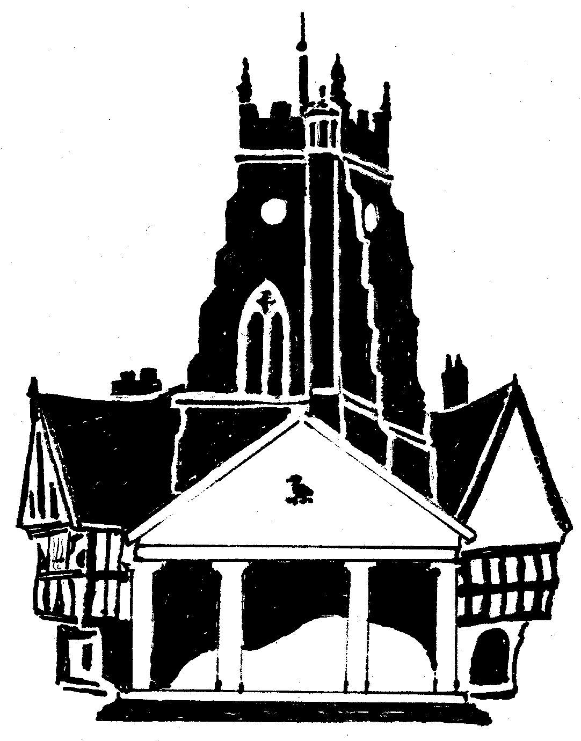  Market Drayton  Town Council
Agenda Item: 8.SF Grass Cutting

Date: 5 October 2023

Appendix : SF80

To consider quotes for the two-year contract to cut the grass on the parks and open spaces.
 | Price Per Cut
 | 2024/25 | 2025/26
Quote A | £2460 | £2460
Quote B | £1710 | £1900
Quote C | £1050 | £1103
Quote D | £2968 | £3263

Insurance certificates, risk assessments and health and safety policies have all been received.

