Finance & General Purposes Committee Meeting | 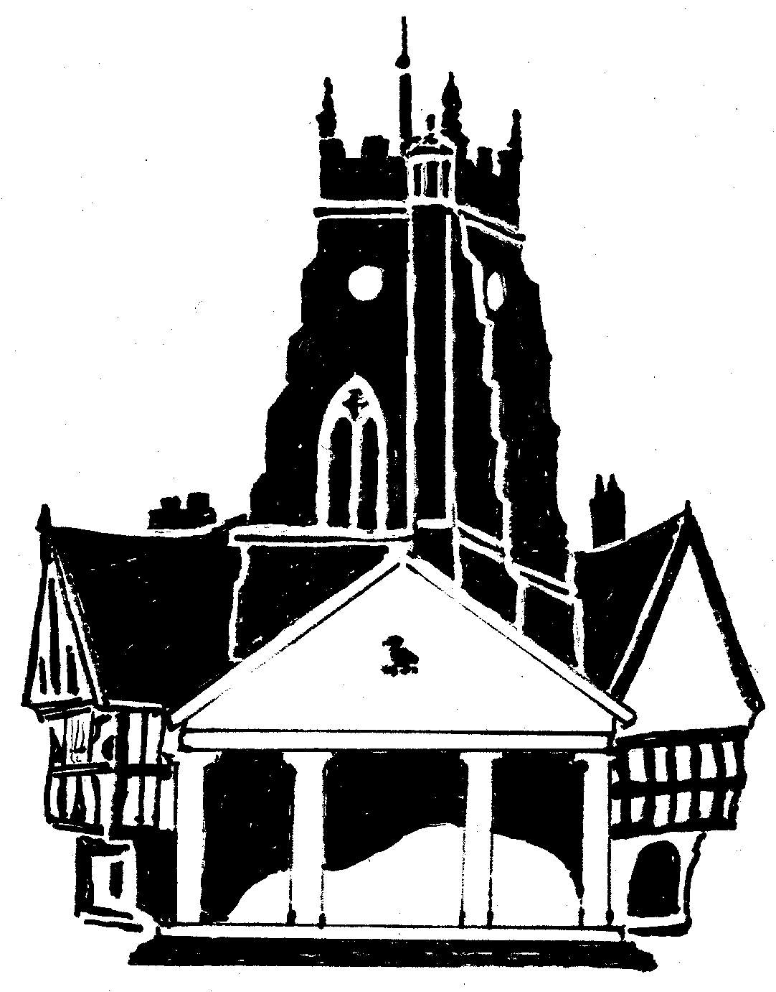  Market Drayton  Town Council
Agenda Item: 5.FG i – Small Grants

Date: 2 November 2023

Appendix : FG95

Organisation | Requested Amount  £ | To Fund | Funded in 2022/23
- Market Drayton Choral Society | £300 | The study and practice of Choral Music to foster public knowledge and appreciation of such music by means of public performance.  The grant would help with the publicity of producing posters and programs. | £0

